LAA General Membership Meeting

June 9, 2026

Summary of Motions / Actions / Discussions
- ATTENDANCE: 51 in-person, 12 on-line
- No significant discussion / motions / actions
Slides & Discussion
- NO DISCUSSION

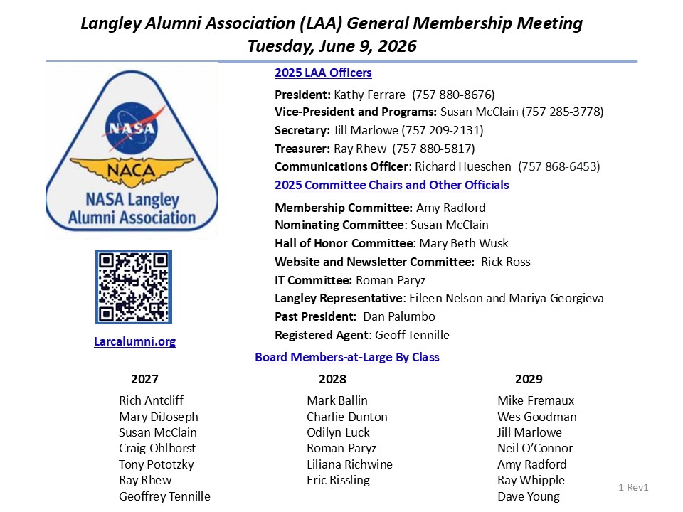
- NO DISCUSSION

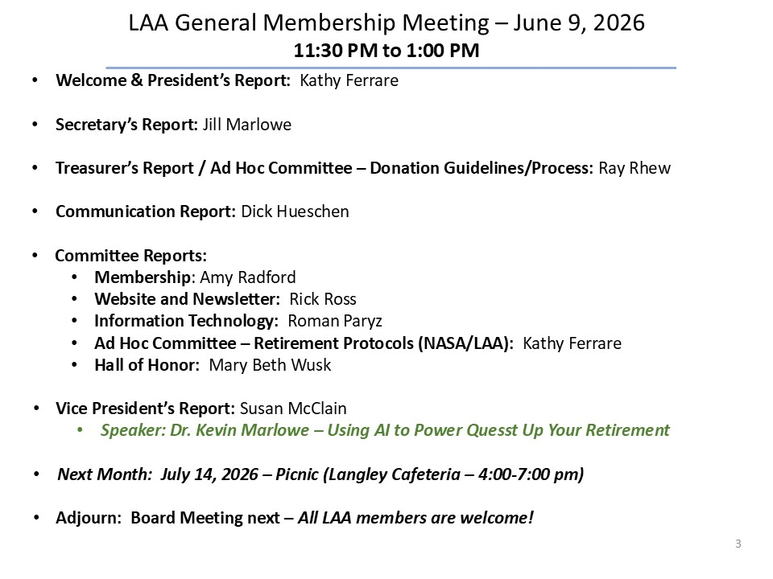
- NO DISCUSSION
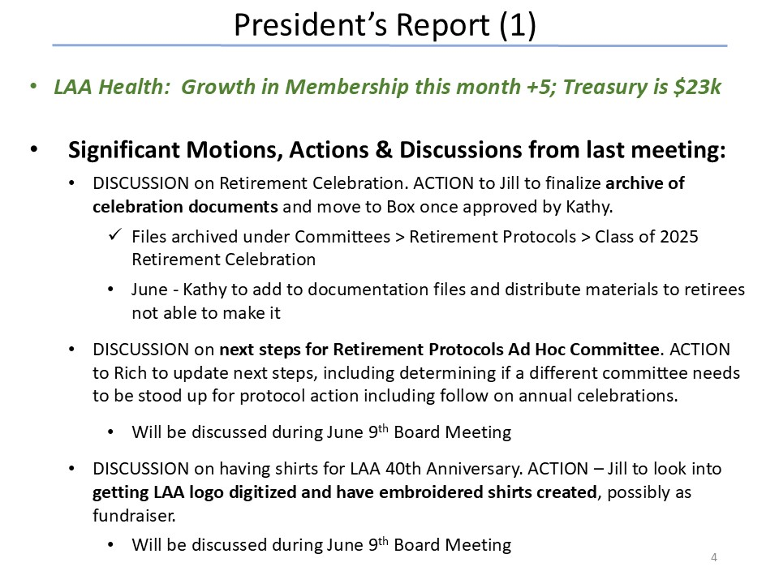
- NO DISCUSSION
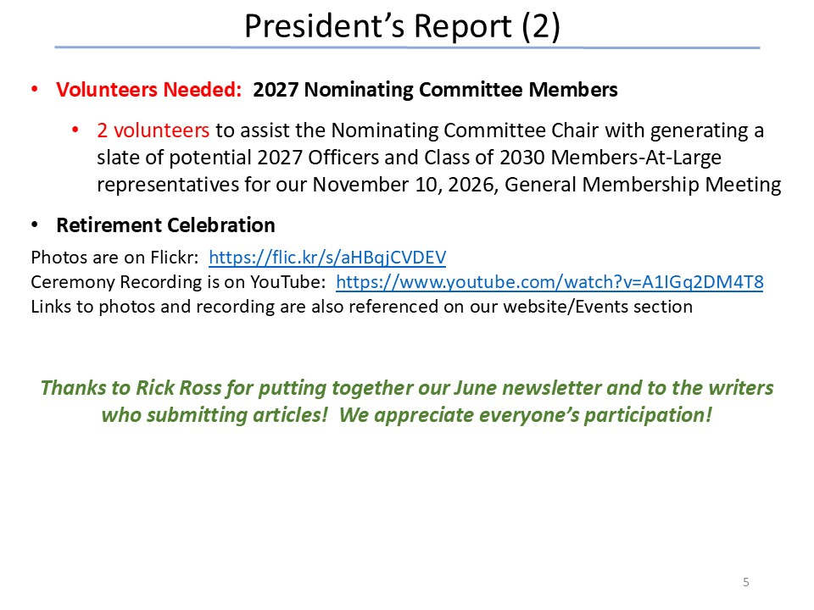
- NO DISCUSSION
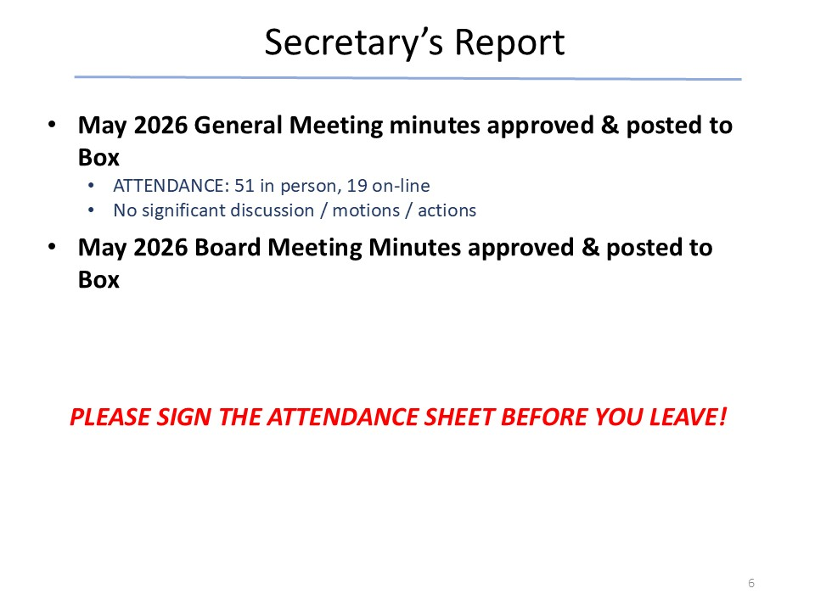
- NO DISCUSSION
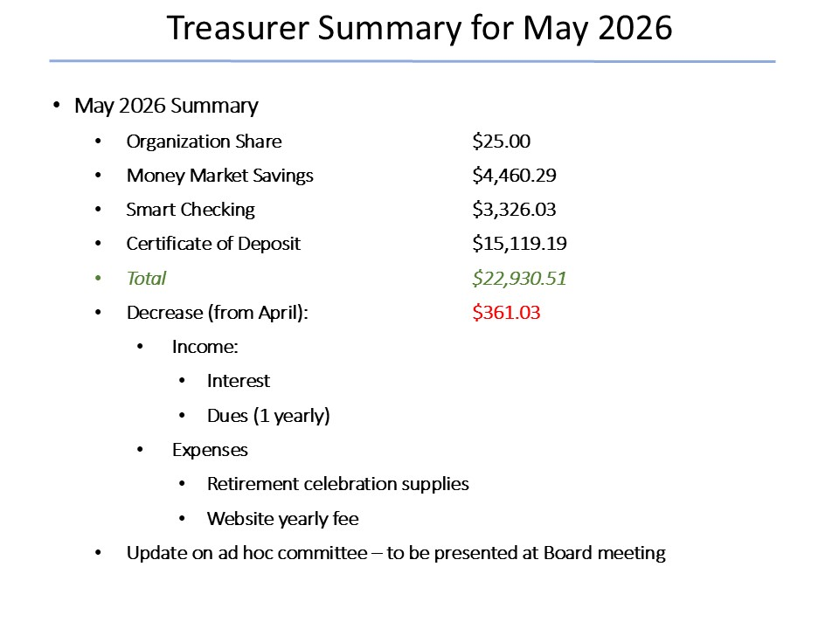
- NO DISCUSSION
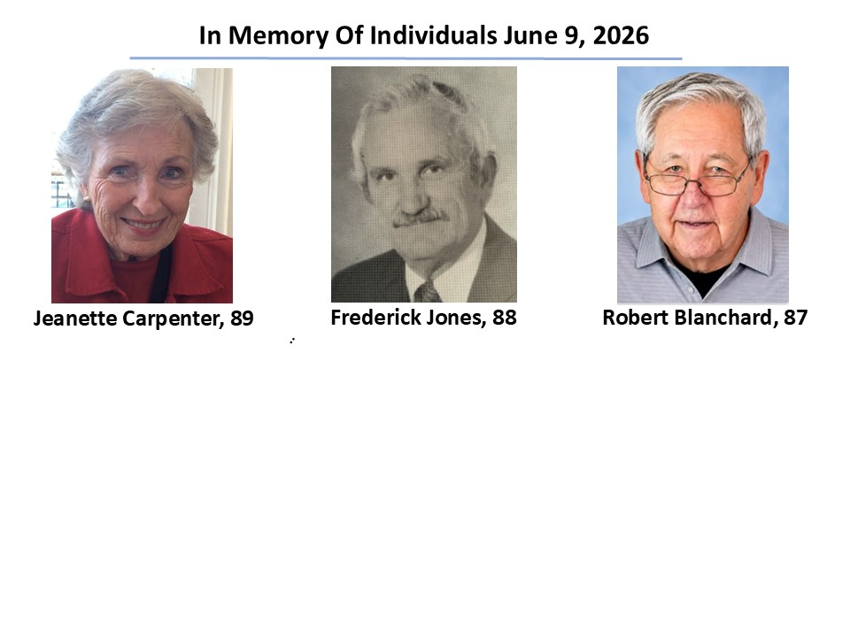
- Last minute addition: Chuck Engel
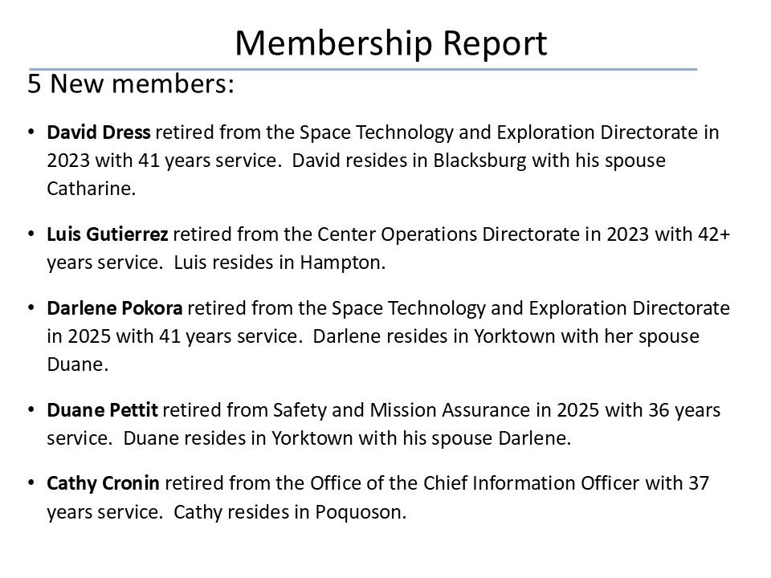
- NO DISCUSSION
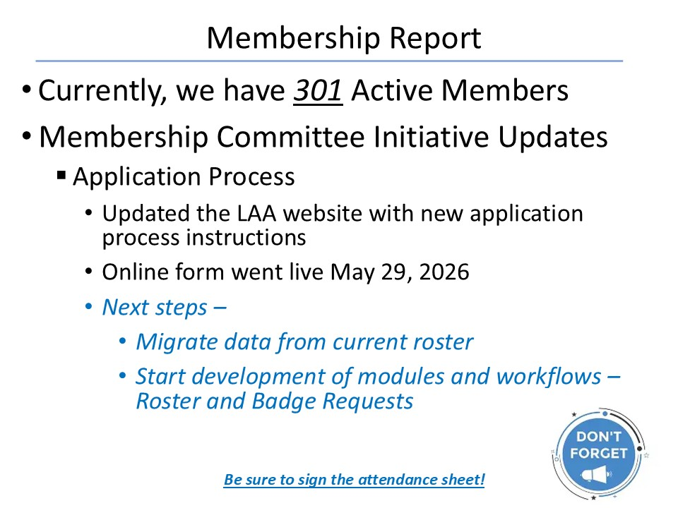
- NO DISCUSSION

- NO DISCUSSION
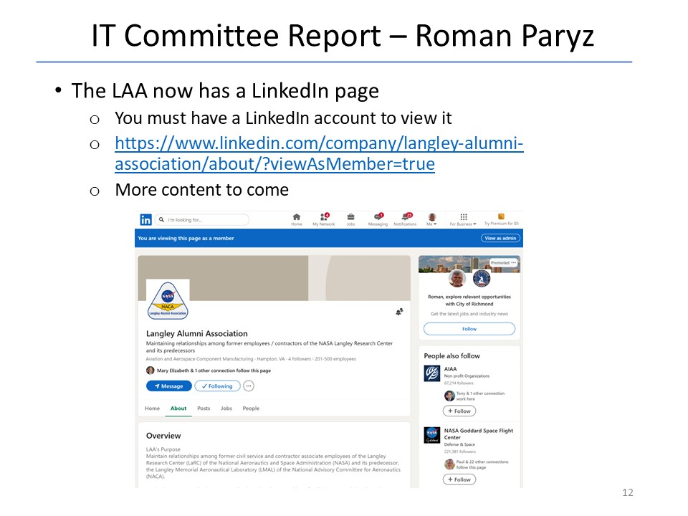
- NO DISCUSSION
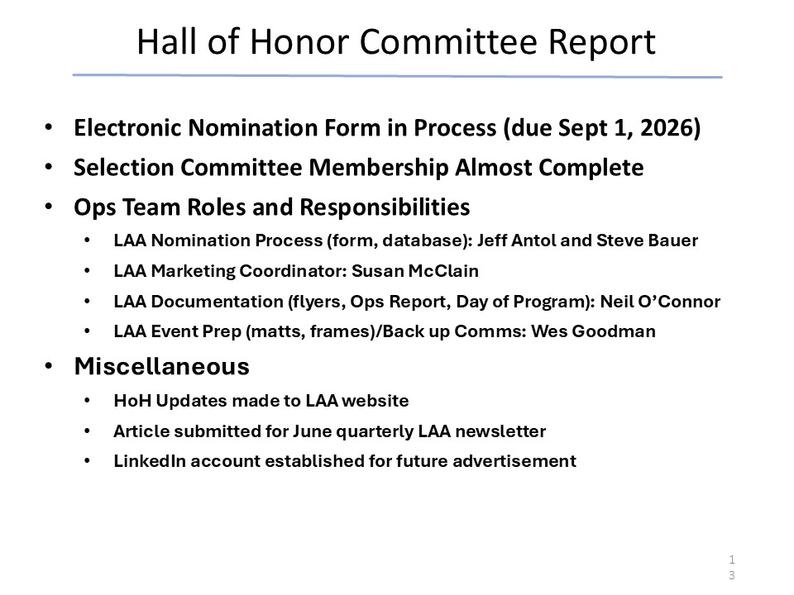
- NO DISCUSSION
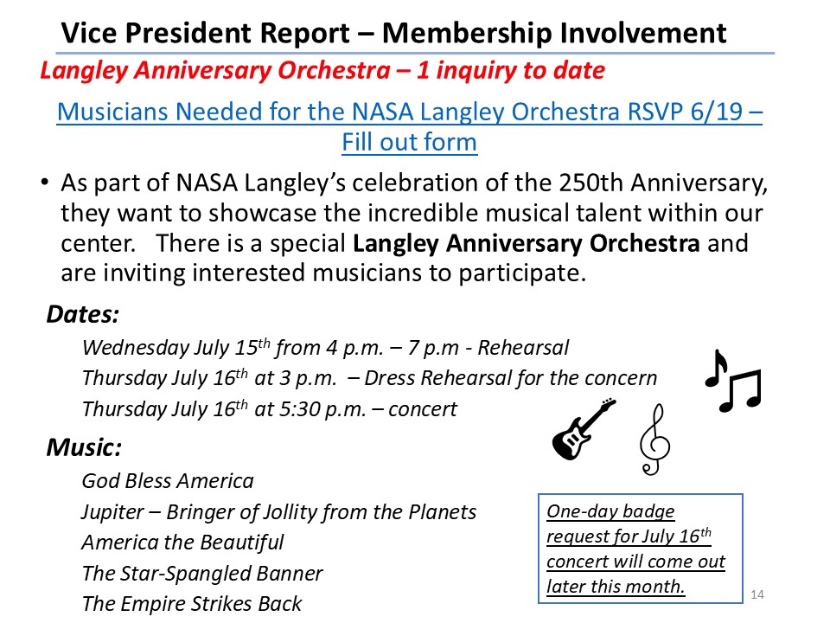
- NO DISCUSSION
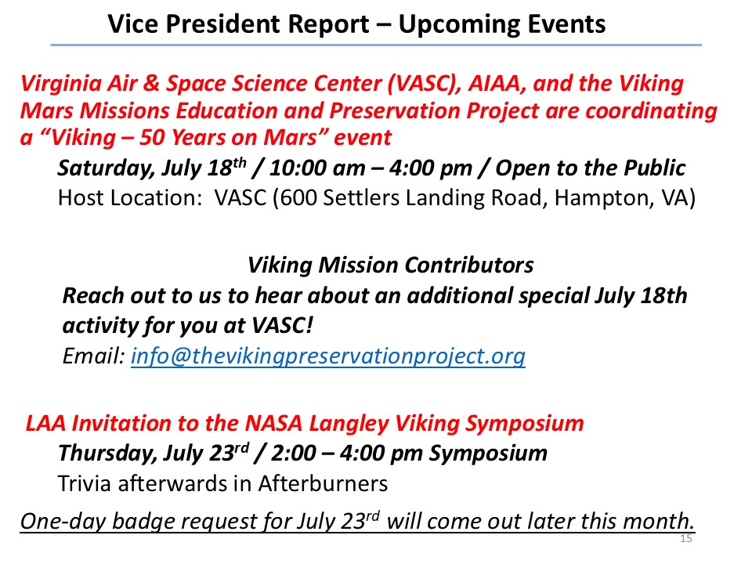
- NO DISCUSSION
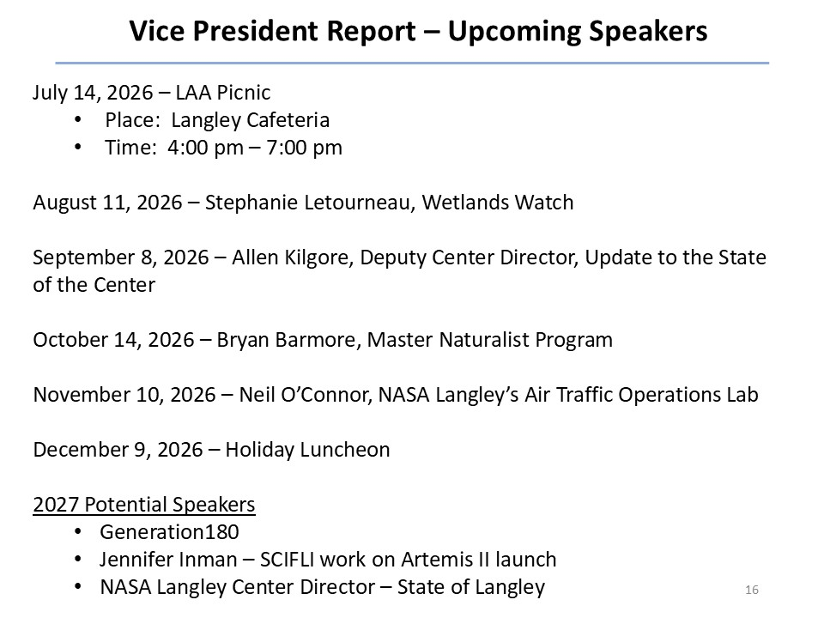
- NO DISCUSSION

- NO DISCUSSION

