LAA General Membership Meeting

May 12, 2026

Summary of Motions / Actions / Discussions
- ATTENDANCE: 51 in person, 19 on line
- No significant discussion / motions / actions

Welcome

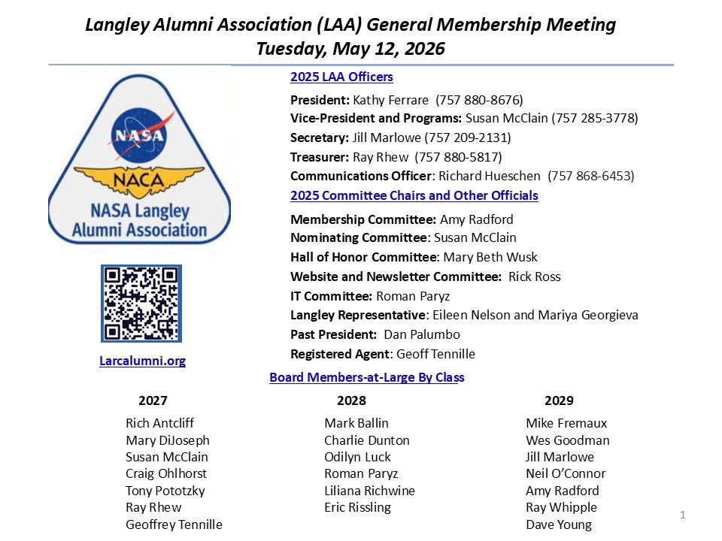
- NO DISCUSSION

Agenda

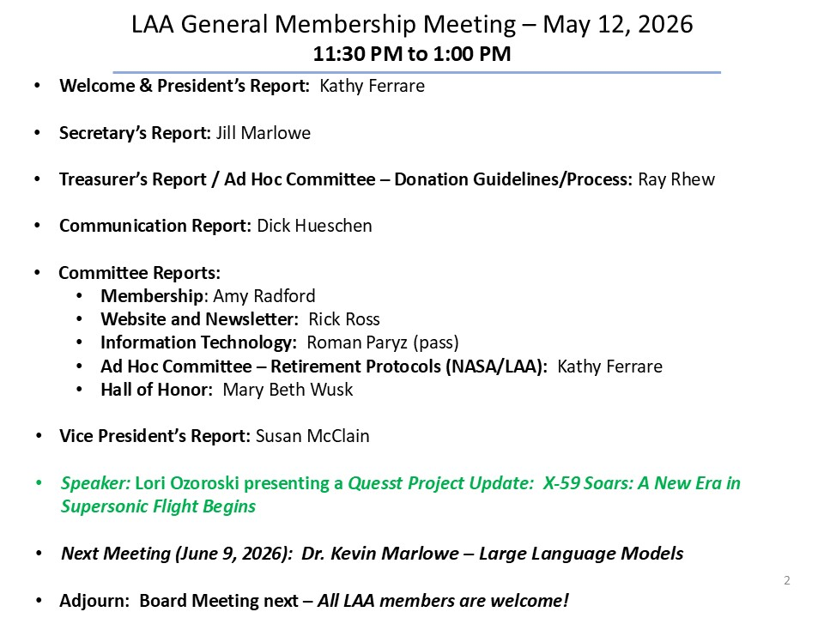
- NO DISCUSSION

President’s Report

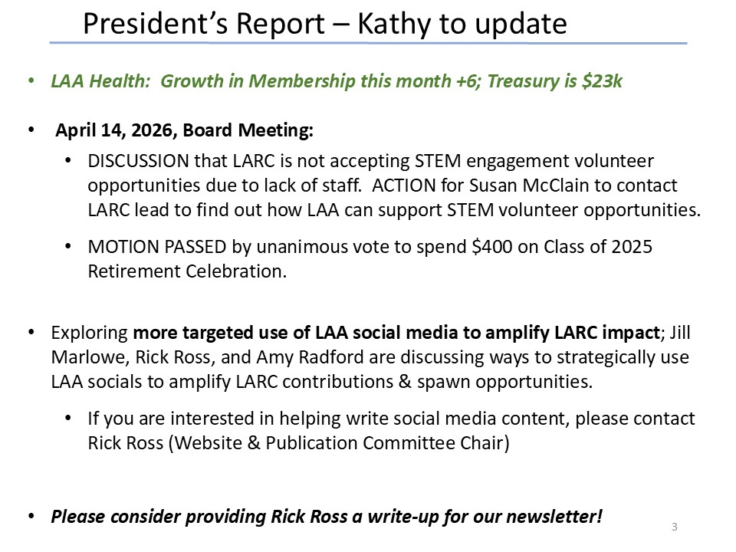
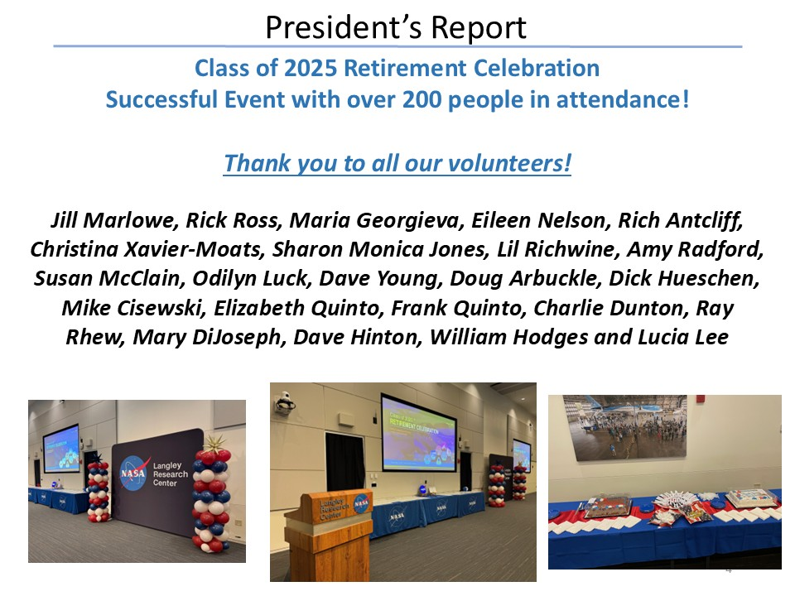
- NO DISCUSSION

Secretary’s Report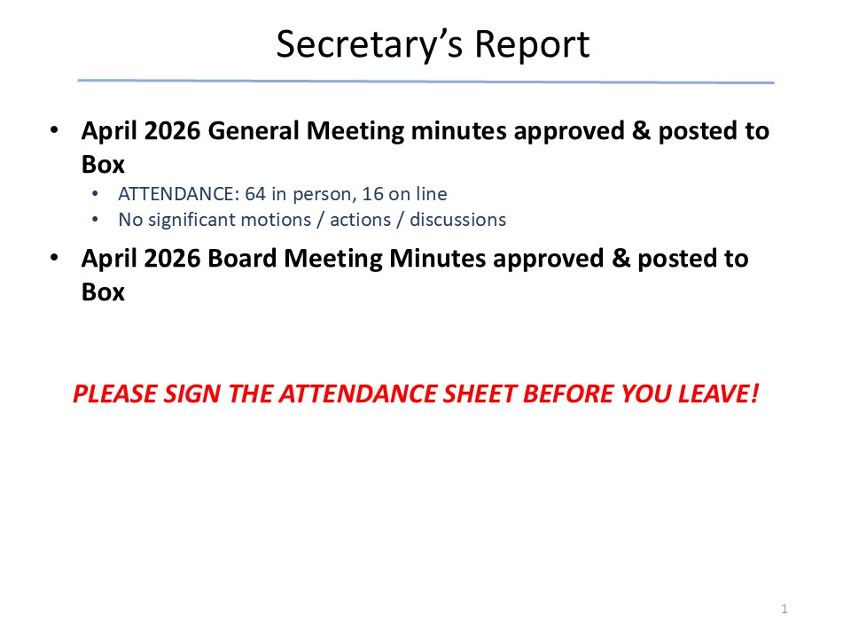
- NO DISCUSSION

Treasurer’s Report

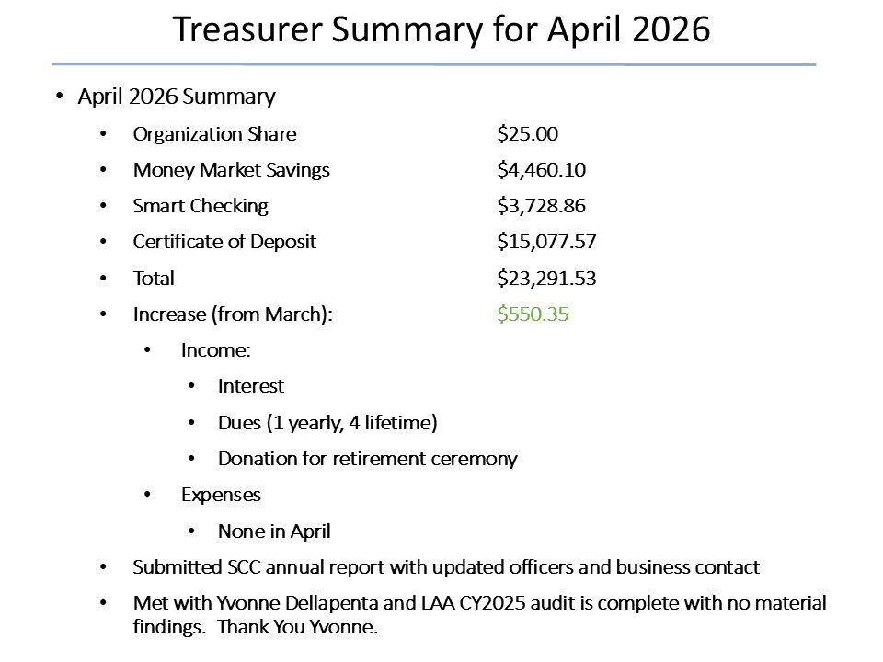
- NO DISCUSSION

Ad Hoc Committee: Donation Guidelines/Process

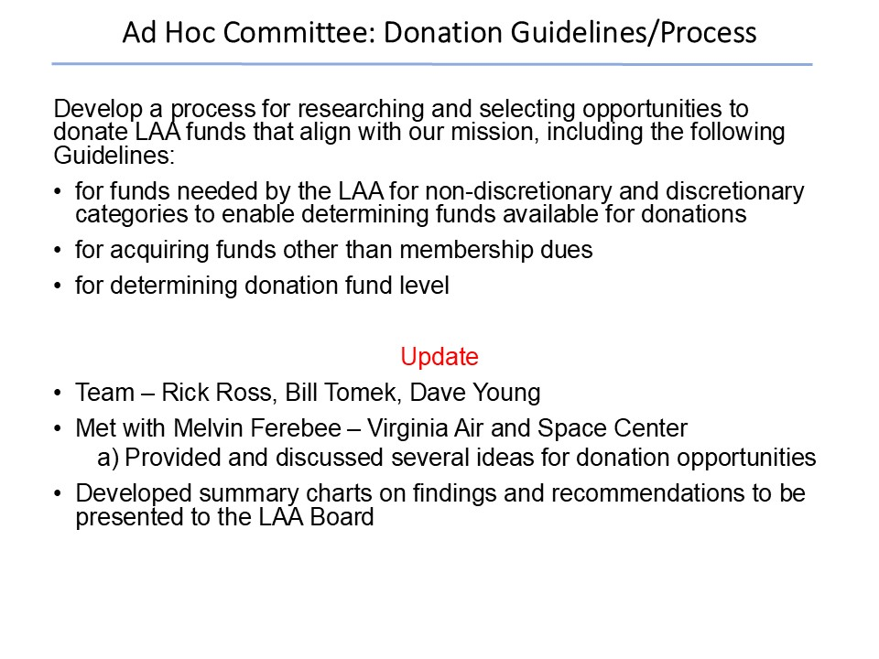
- NO DISCUSSION

In Memorium

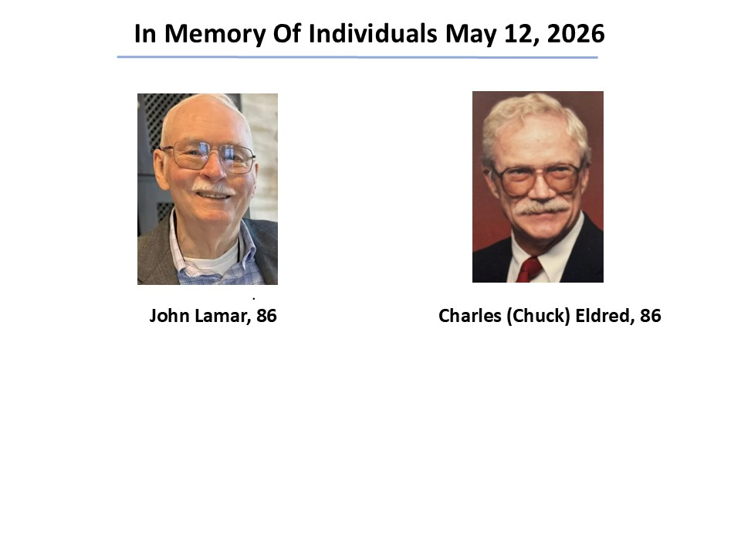
- NO DISCUSSION

Membership Report

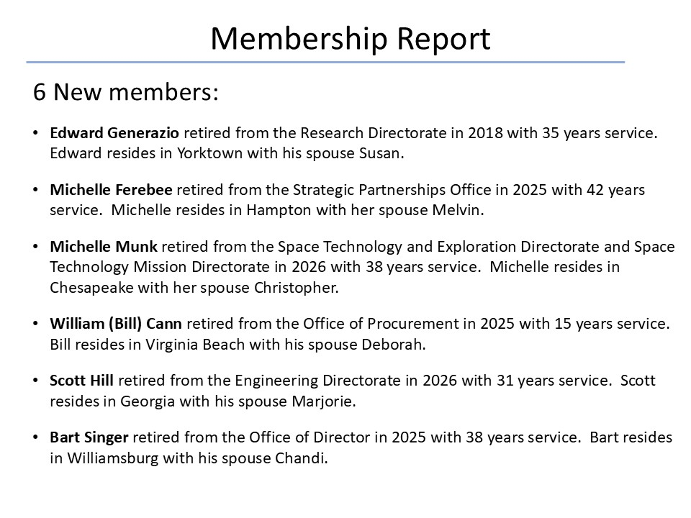
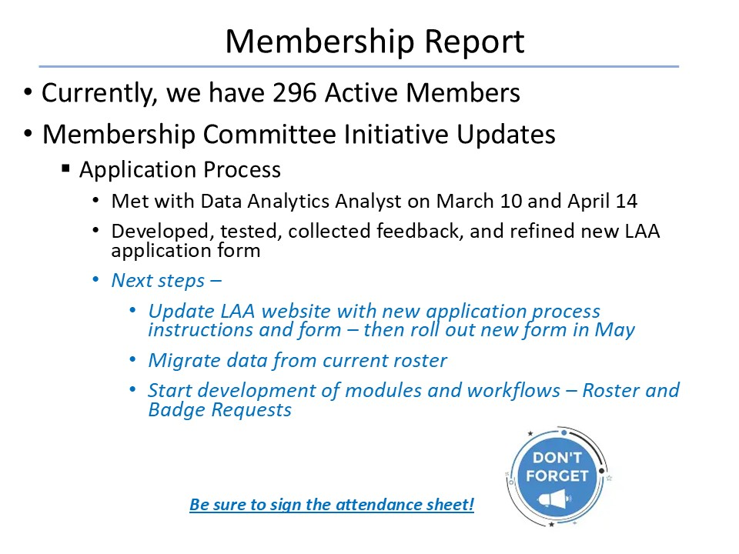
- NO DISCUSSION

Web Site & Publications

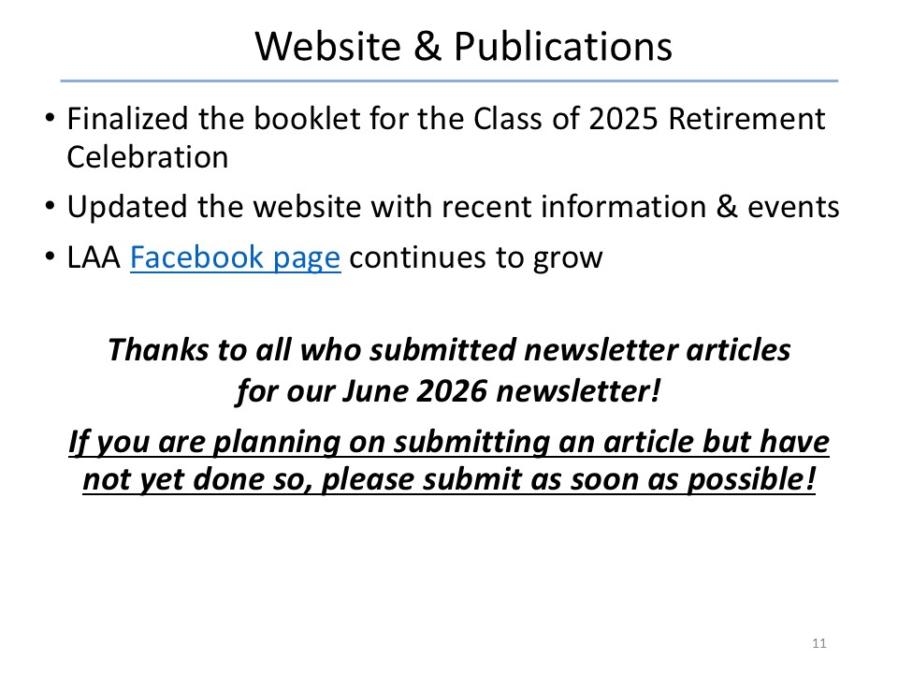
- NO DISCUSSION

Ad Hoc Committee: Retirement Protocols

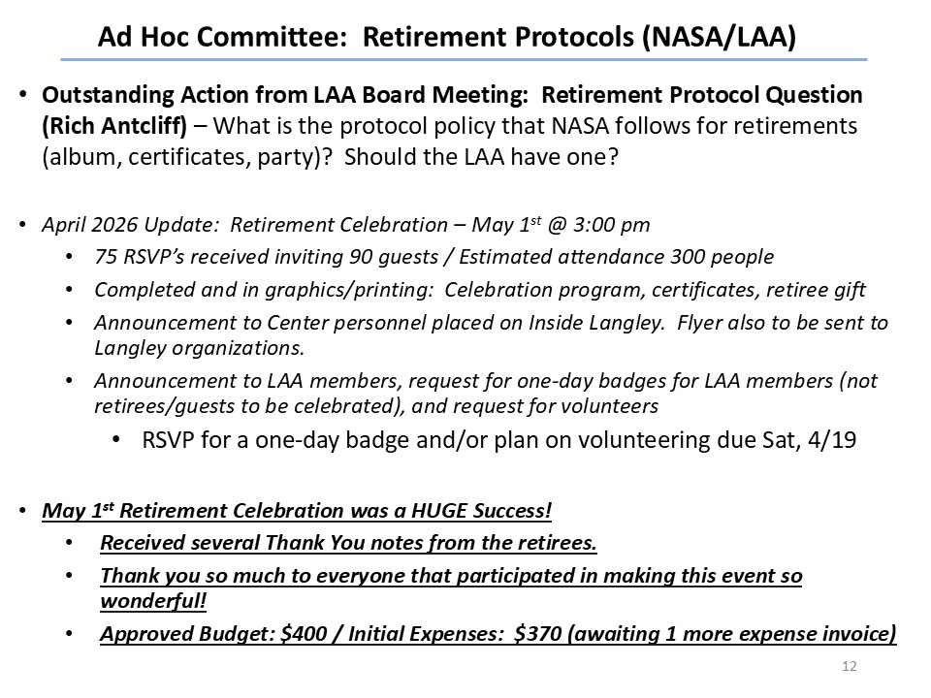
- NO DISCUSSION

Hall of Honor

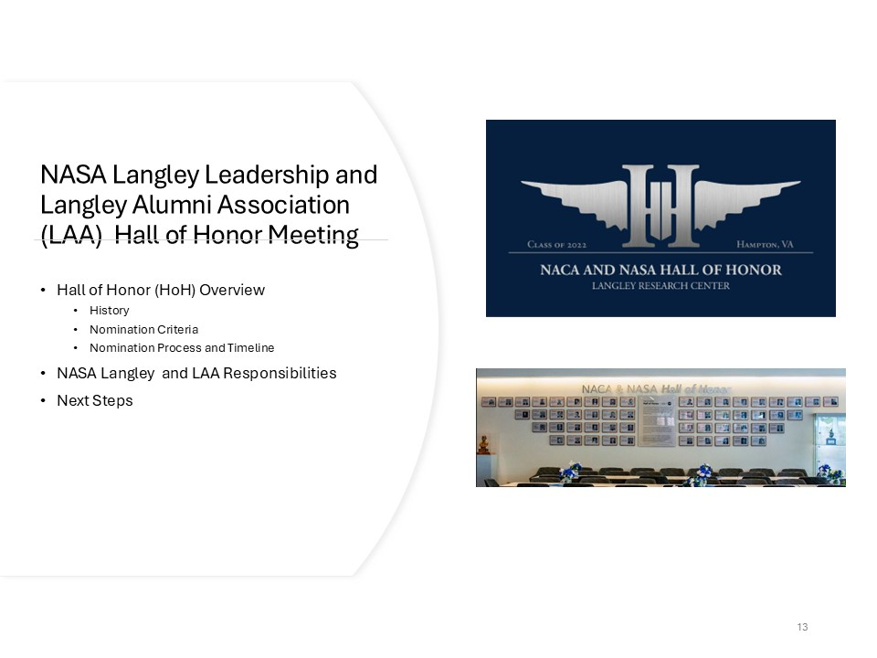
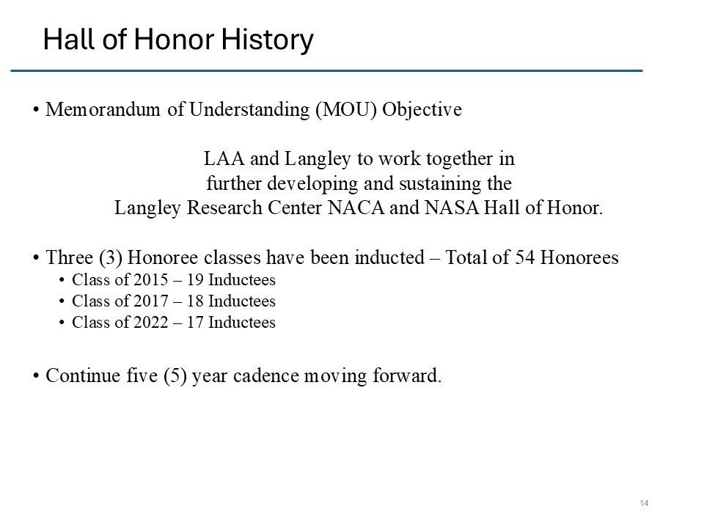
- NO DISCUSSION
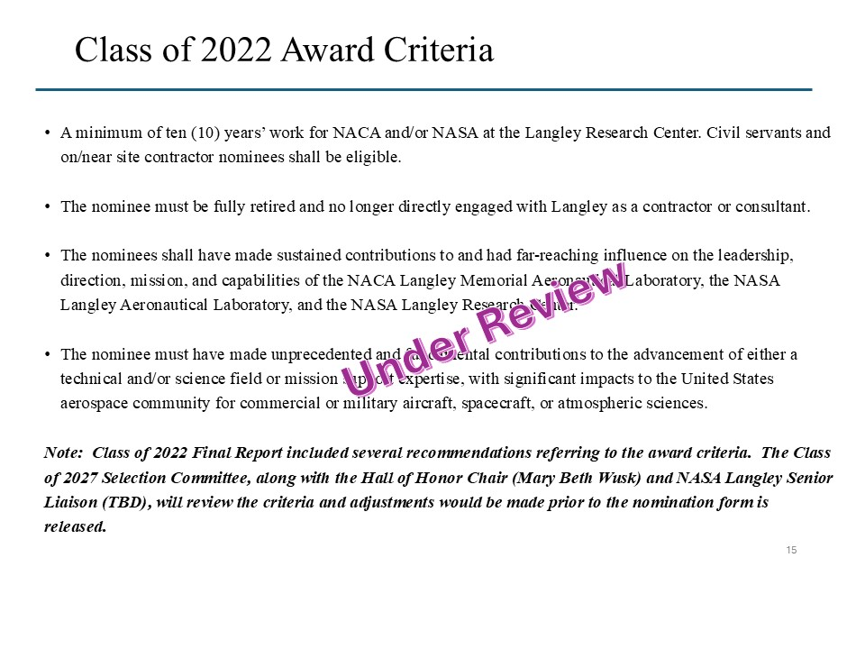
- NO DISCUSSION
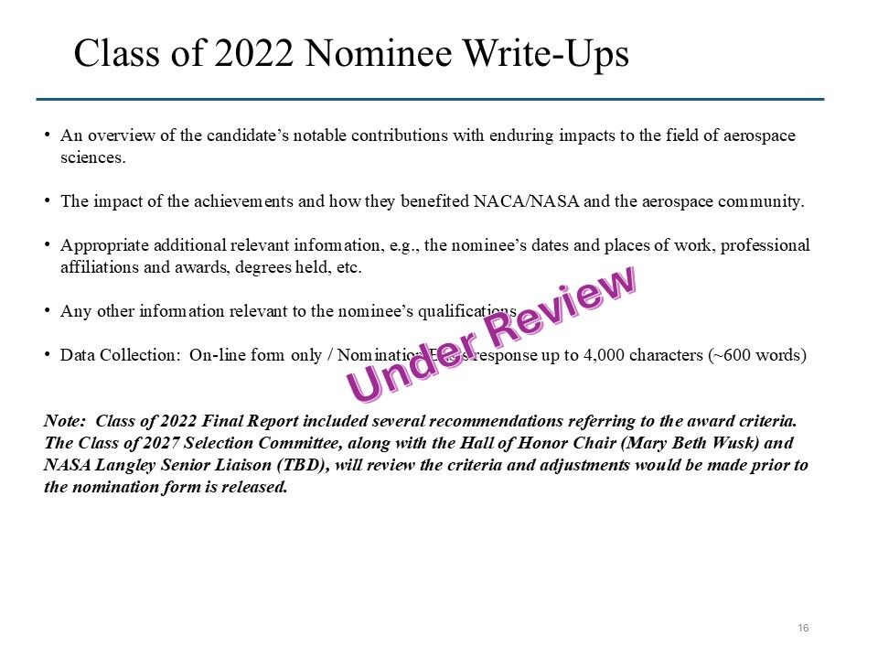
- NO DISCUSSION

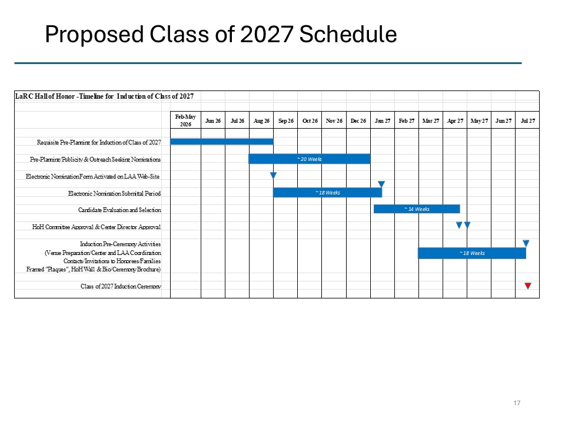
- NO DISCUSSION
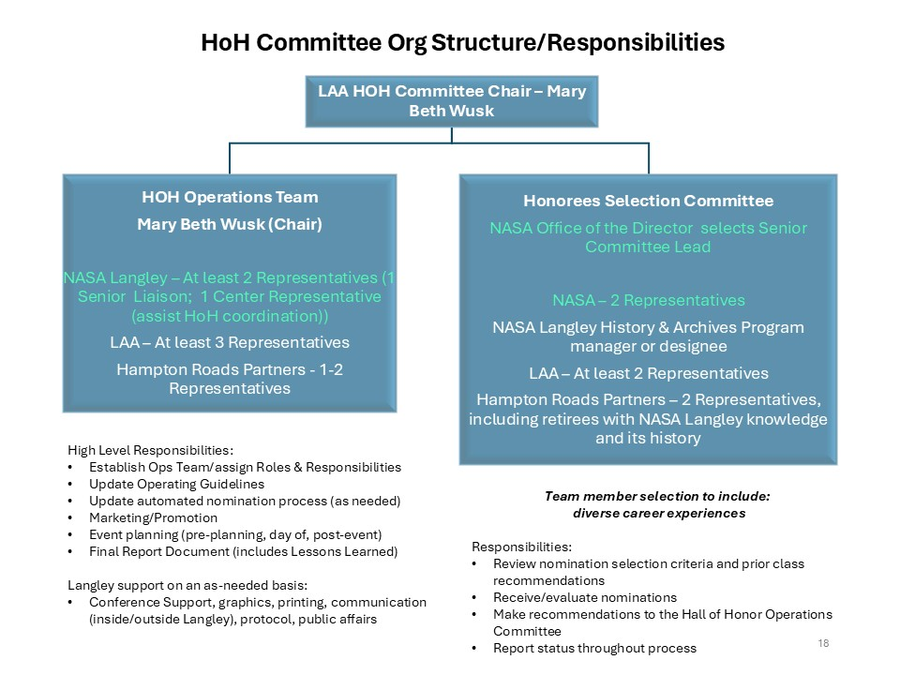
- NO DISCUSSION
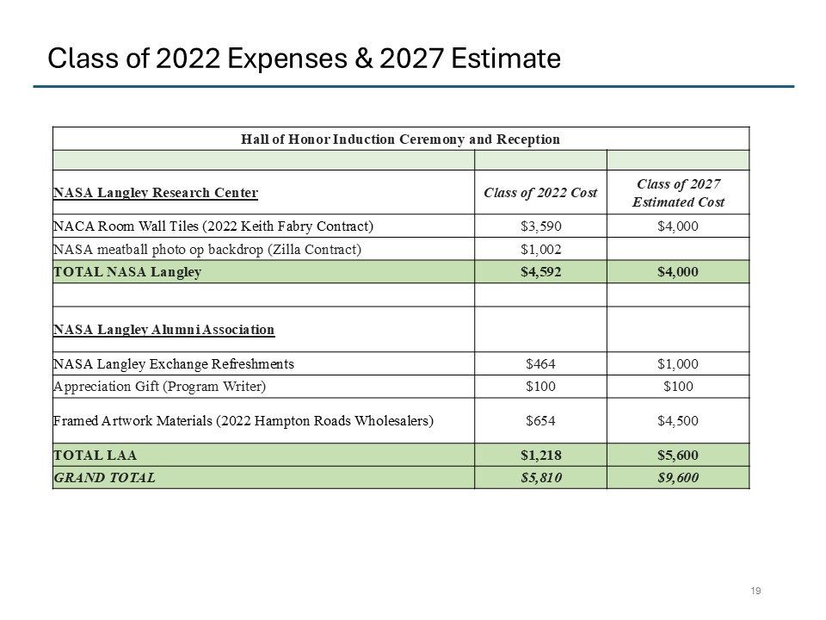
- NO DISCUSSION

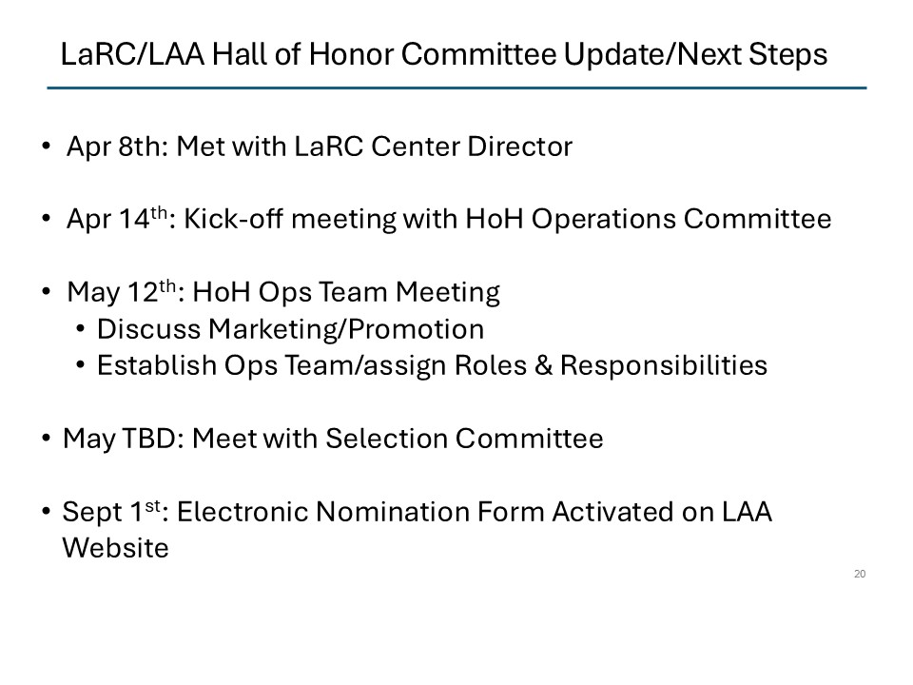
- NO DISCUSSION

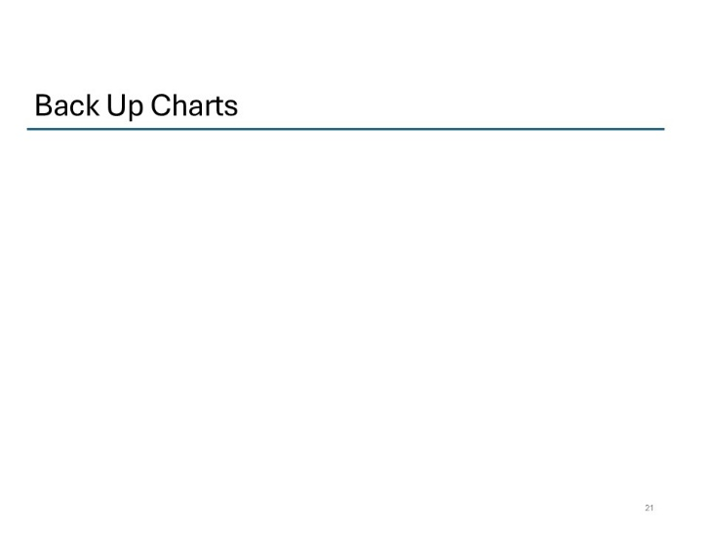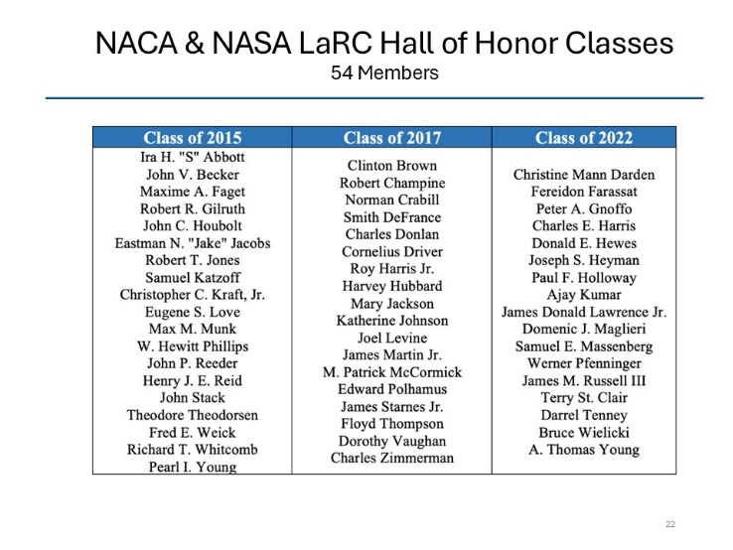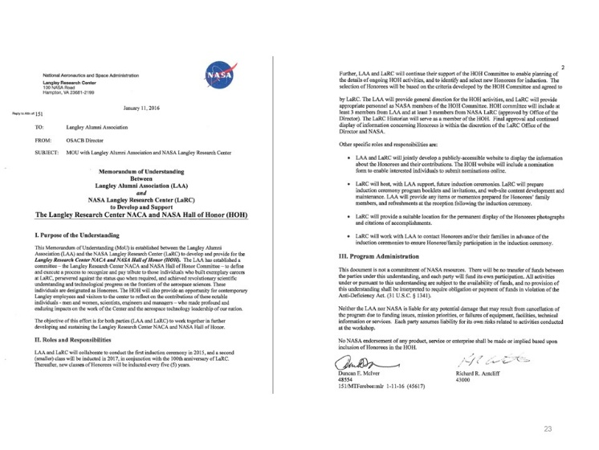
- NO DISCUSSION

Vice President’s Report
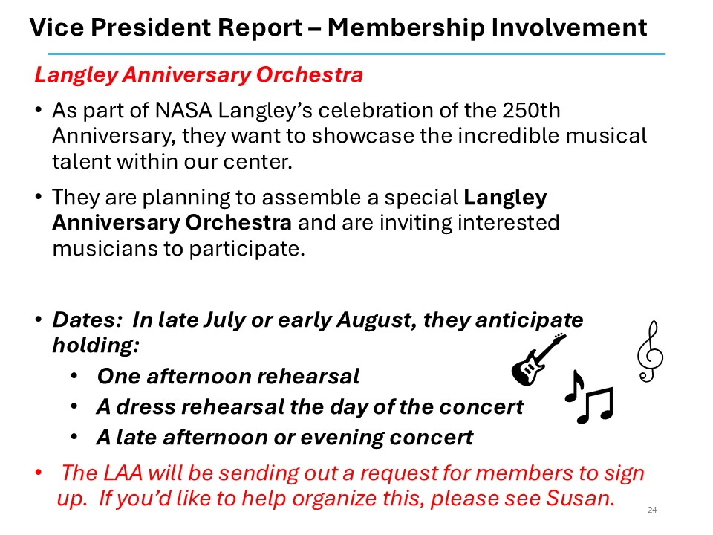

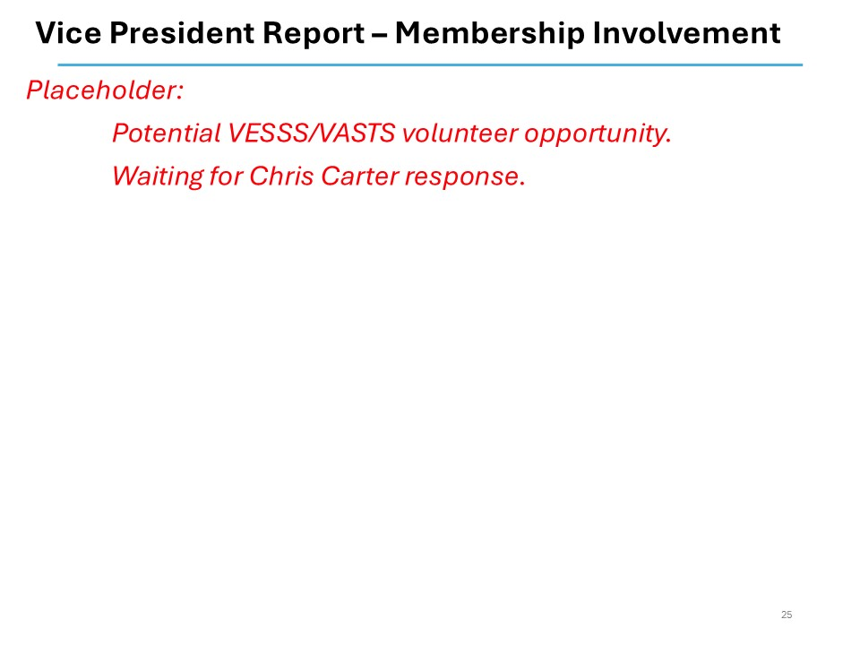
- Concert is on! July 16 at 5:30 with single rehearsal on July 15; participant sign up will be sent by Dick soon.

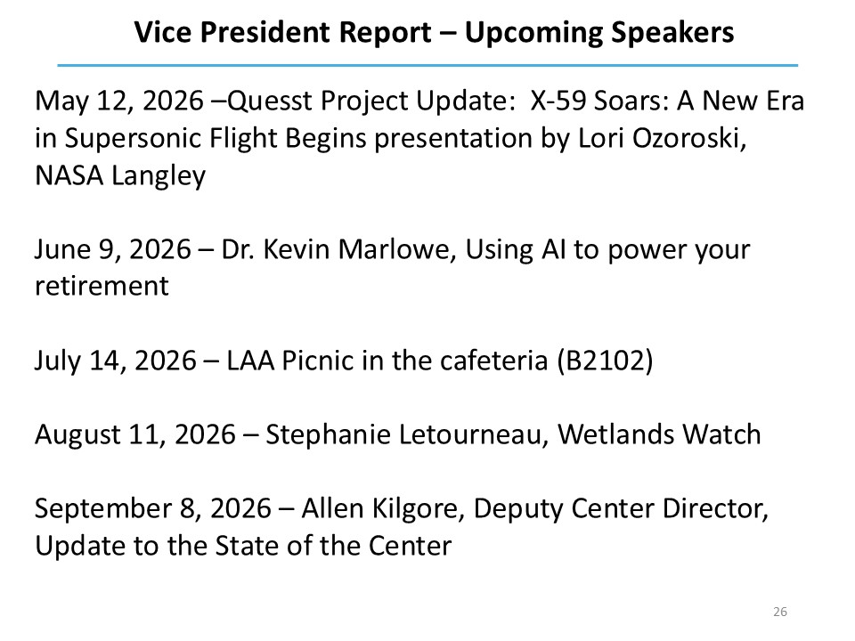
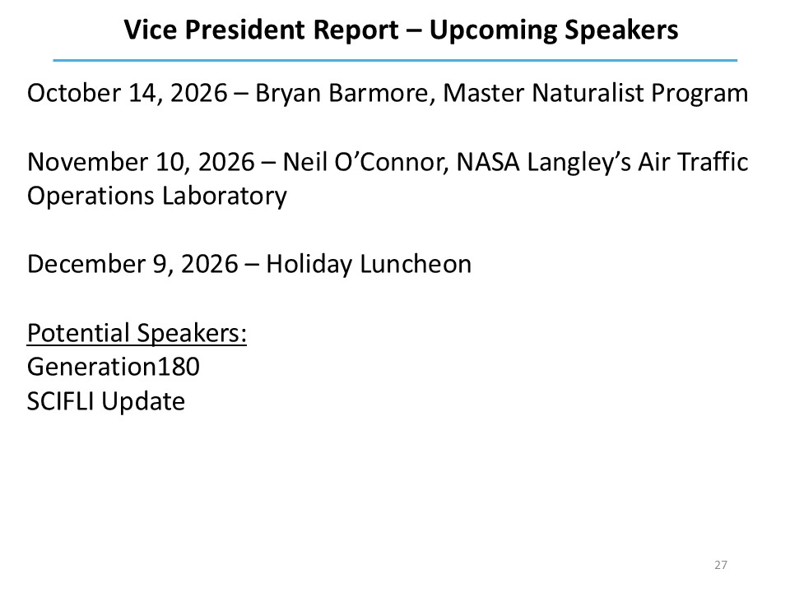
- NO DISCUSSION

Today’s Speaker

- Good Q&A, NO DISCUSSION

