LAA General Membership Meeting

April 14, 2026

Summary of Motions / Actions / Discussions
- ATTENDANCE: 64 in person, 16 on line
- DISCUSSION – membership alerted to issue with some new activity badges (must get correct badge), see format for correct badges in Membership slide

Welcome
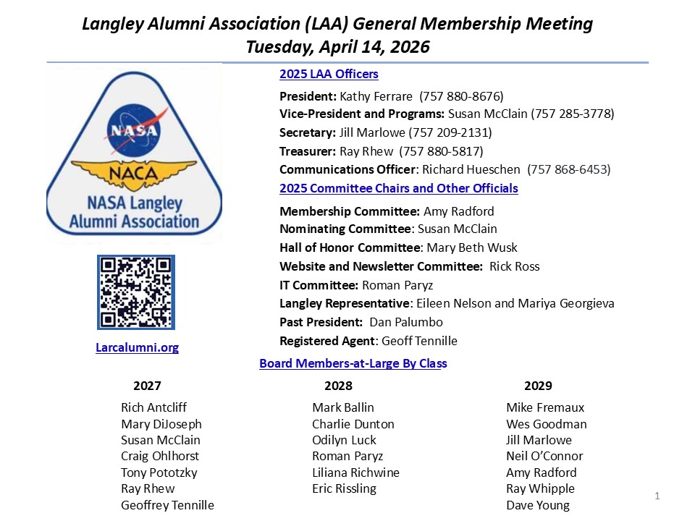
- NO DISCUSSION

Agenda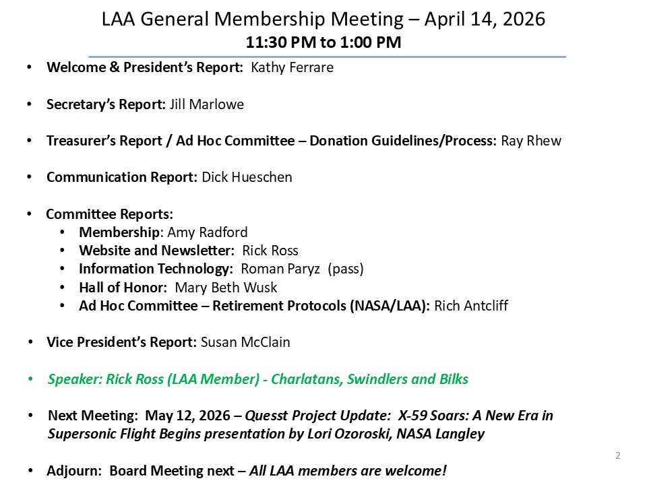
- NO DISCUSSION

President’s Report

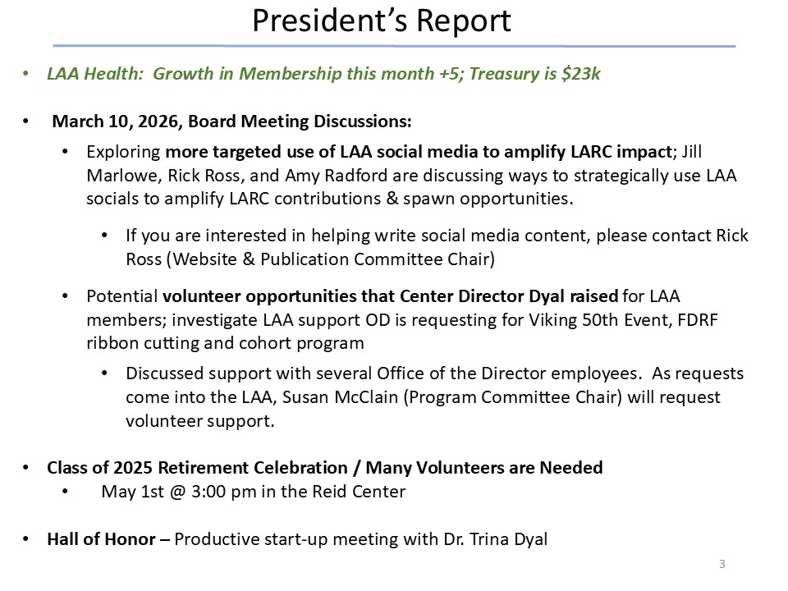
- NO DISCUSSION

Secretary’s Report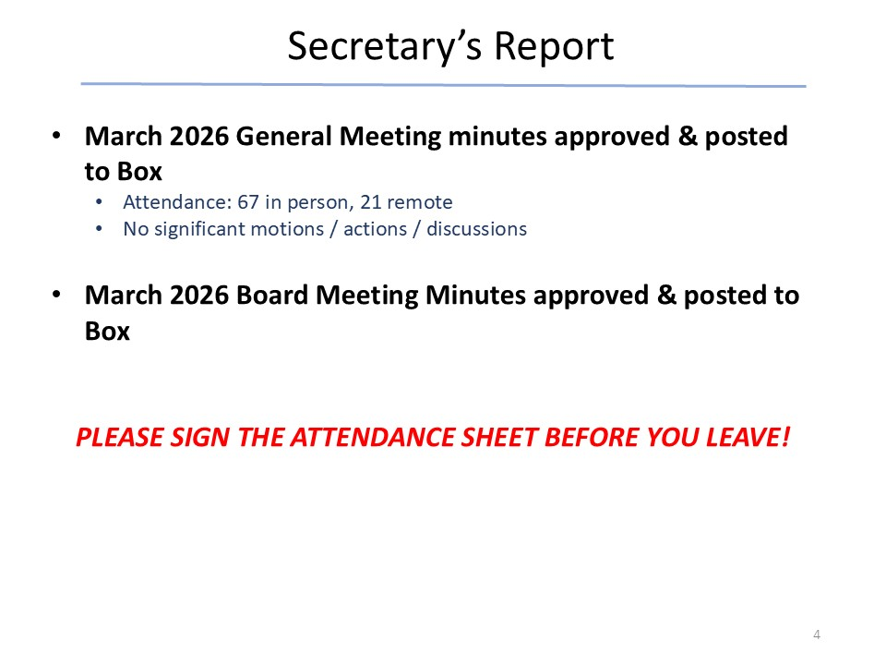
- NO DISCUSSION

Treasurer’s Report

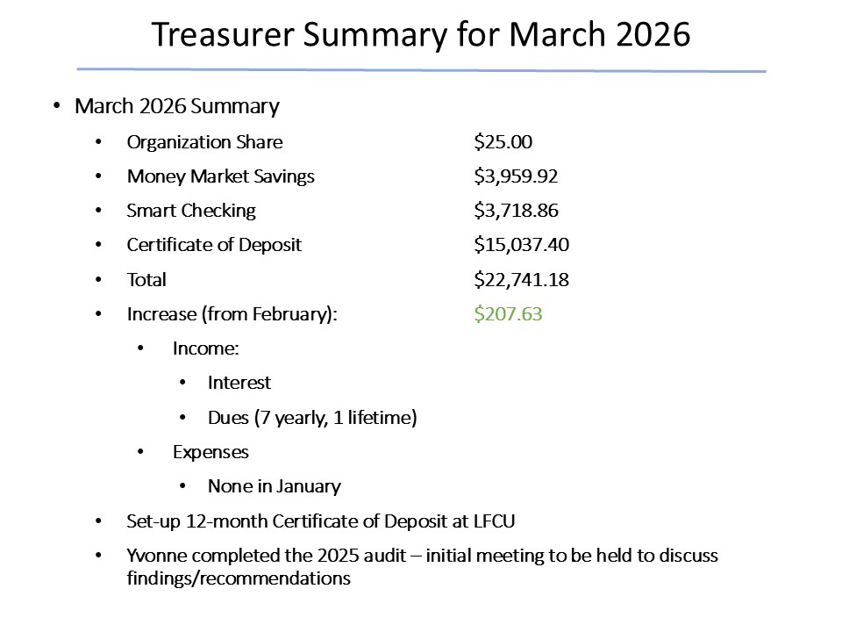
- NO DISCUSSION

Ad Hoc Committee: Donation Guidelines/ Process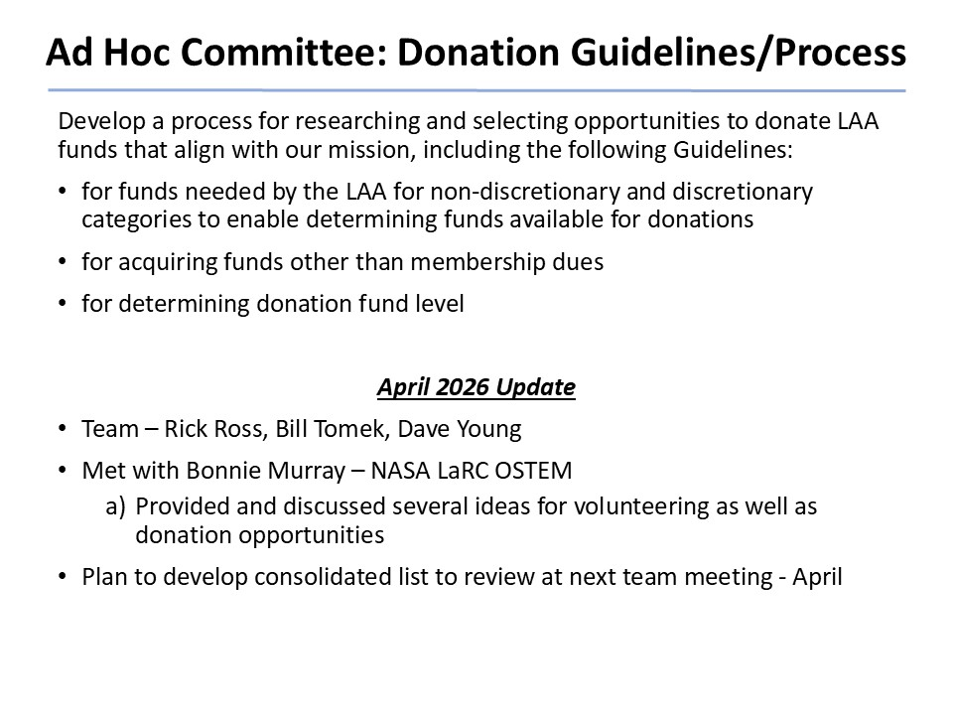
- NO DISCUSSION

In Memorium

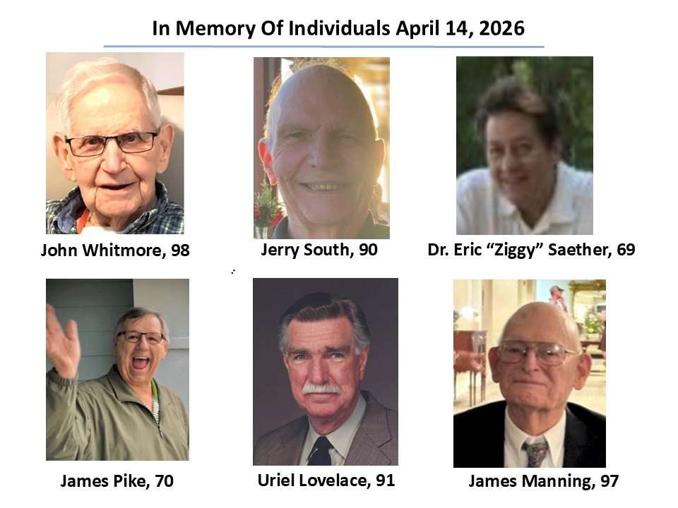
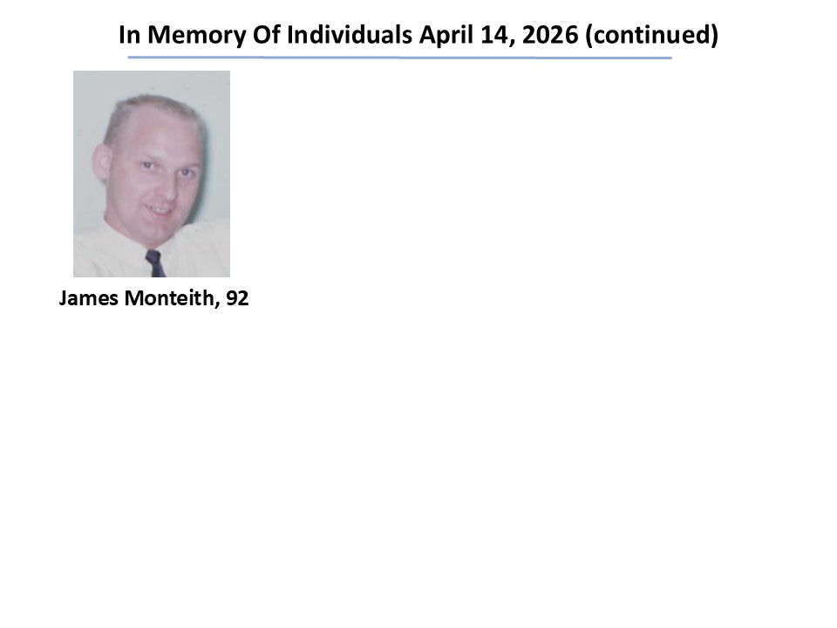
- NO DISCUSSION

Membership Report
- NO DISCUSSION
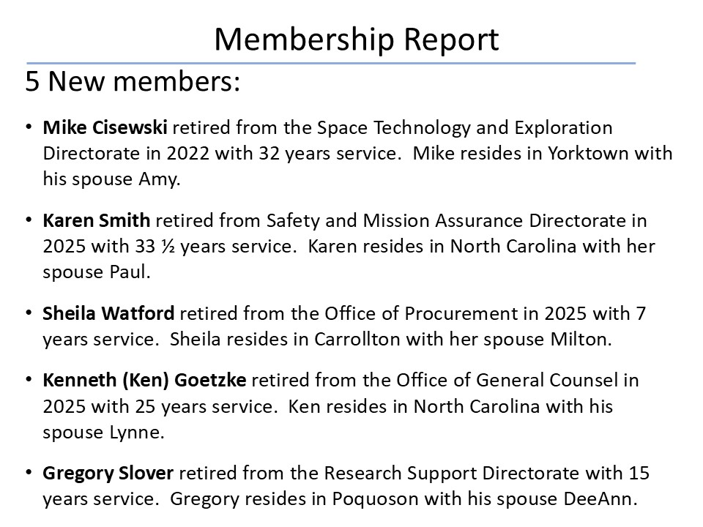
- NO DISCUSSION

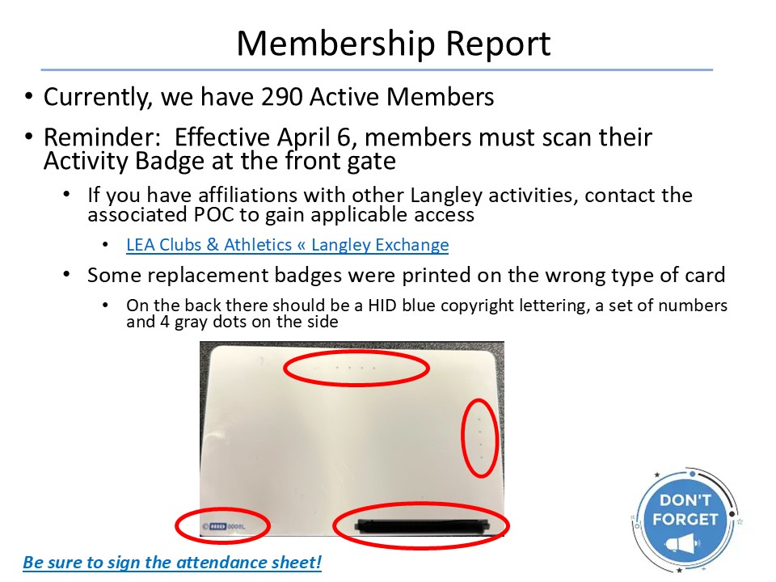
- NO DISCUSSION

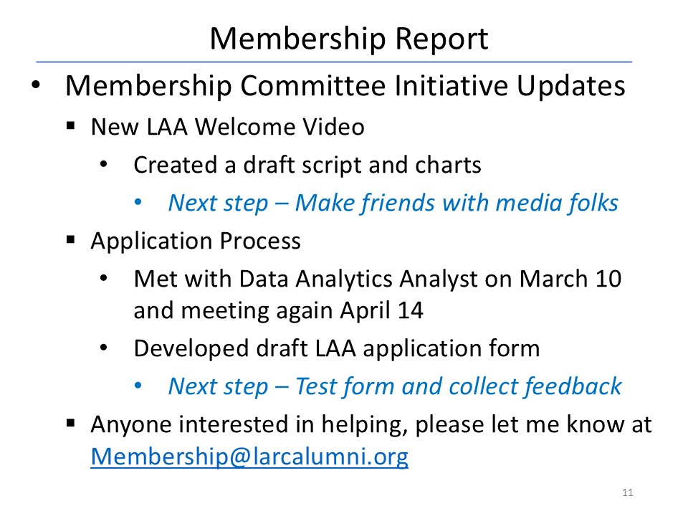
- NO DISCUSSION

Website & Publications
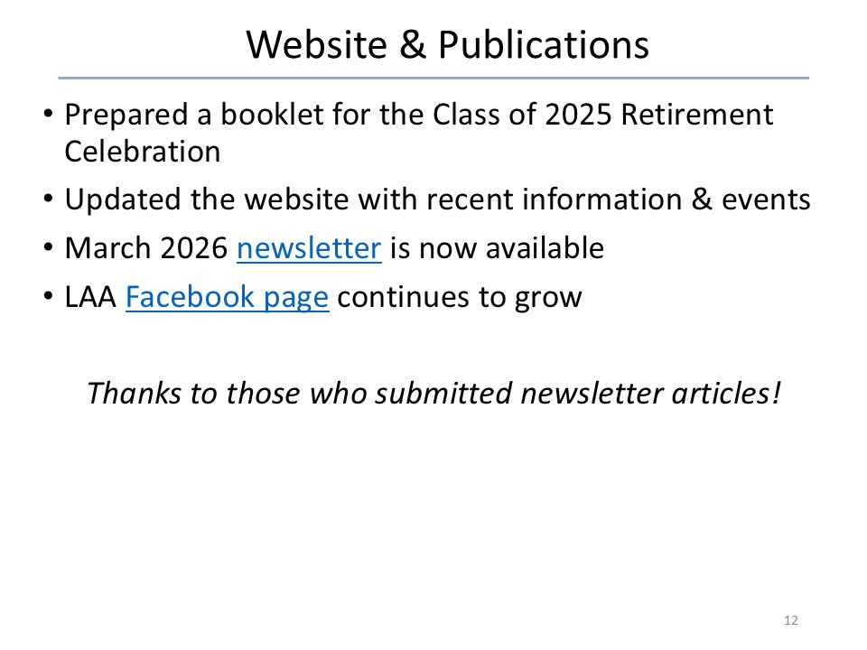
- NO DISCUSSION

Hall of Honor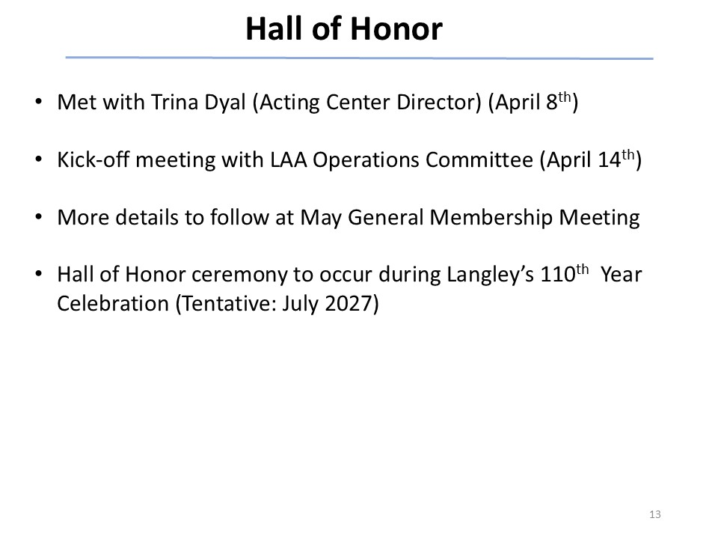
- NO DISCUSSION

Ad Hoc Committee: Retirement Protocols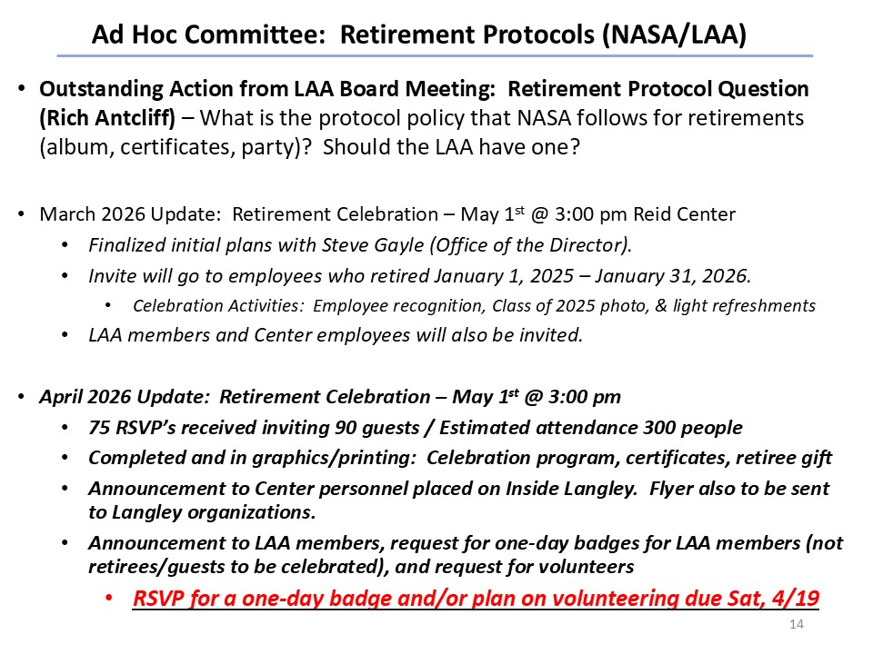
- NO DISCUSSION

Vice President’s Report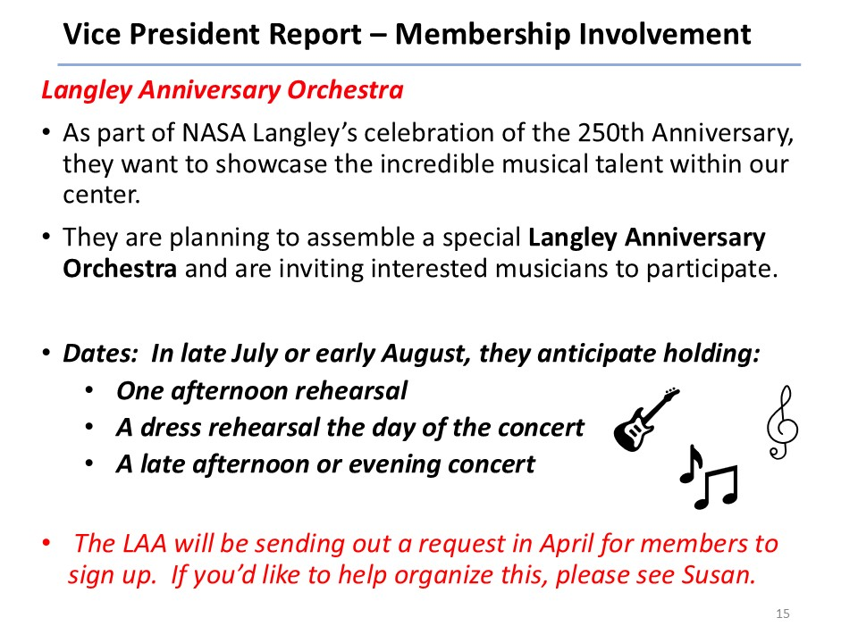
- NO DISCUSSION

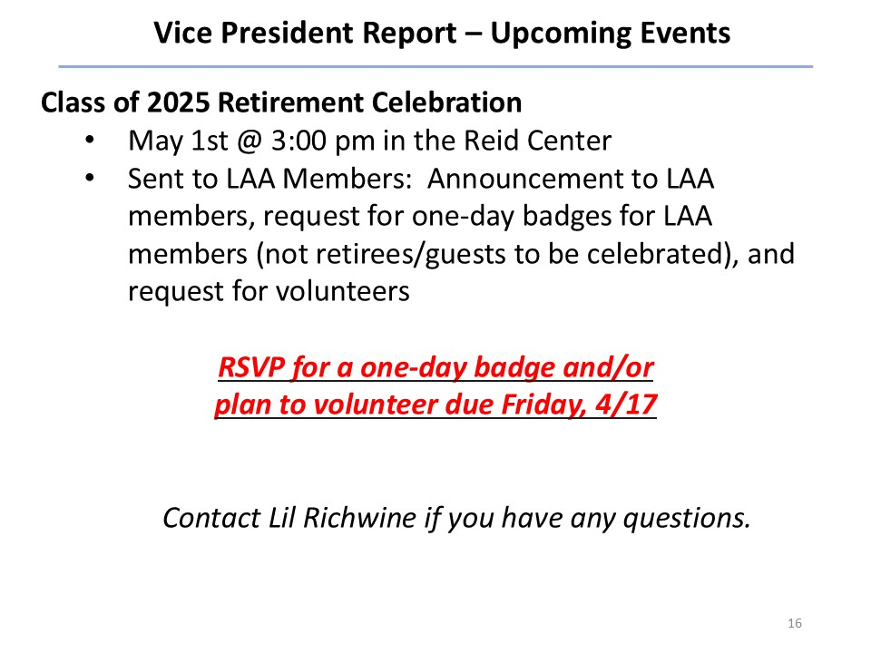
- NO DISCUSSION

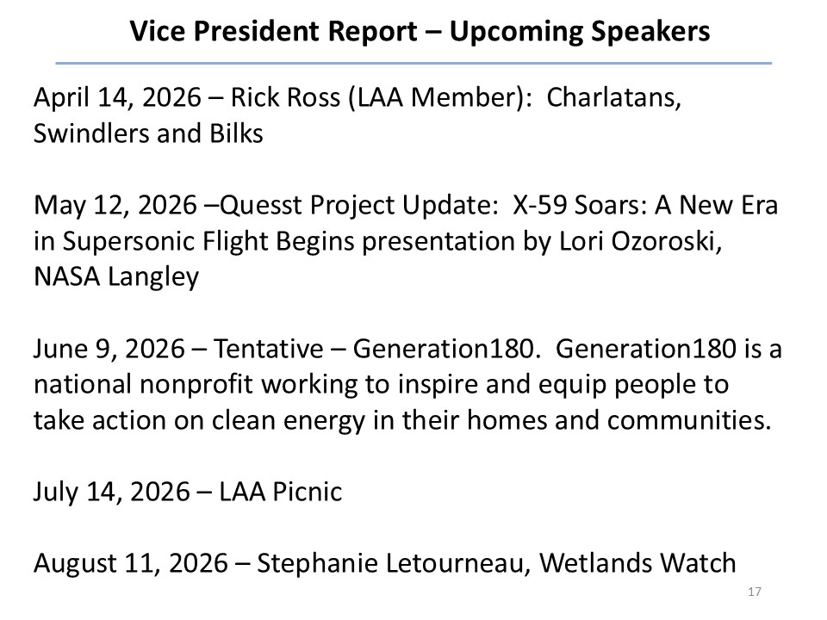
- Change to June: Dr. Kevin Marlowe on “Using AI to Power Up Your Retirement”

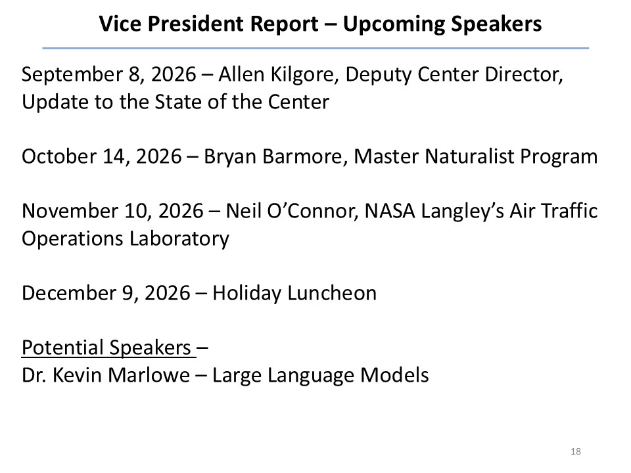
- NO DISCUSSION
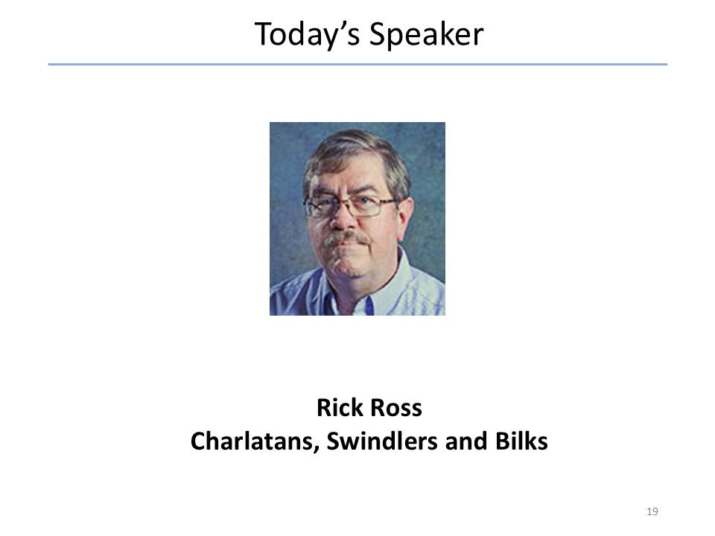
- NO DISCUSSION

