LAA General Membership Meeting

March 10, 2026

Summary of Motions / Actions / Discussions
- ATTENDANCE: 67 in person, 21 on line
- DISCUSSION – membership alerted to new activity badges, must be obtained before 4/6
- DISCUSSION – Excellent presentation by Center Director Dyal on the State of the LaRC, who also shared new opportunities for LAA volunteers including FDRF ribbon cutting, Leadership Cohort program teaching/mentoring, and Langley Anniversary Orchestra

Welcome
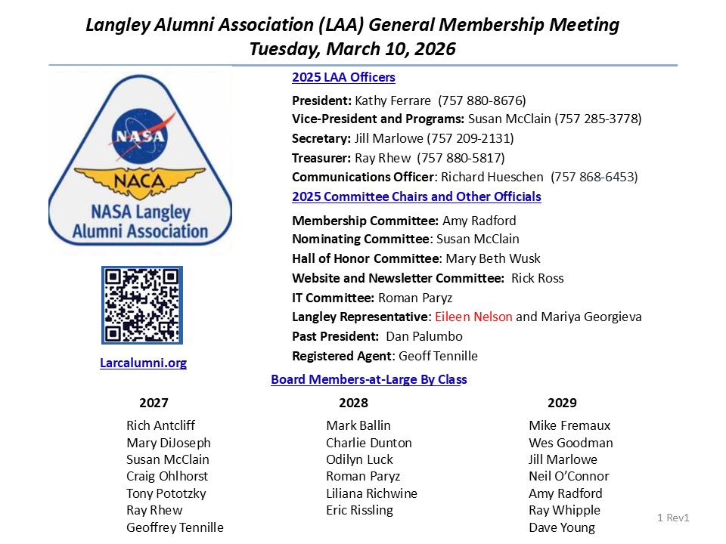
- Welcome to Eileen Nelson, new OD Liaison, taking over for Jessica Friz

Agenda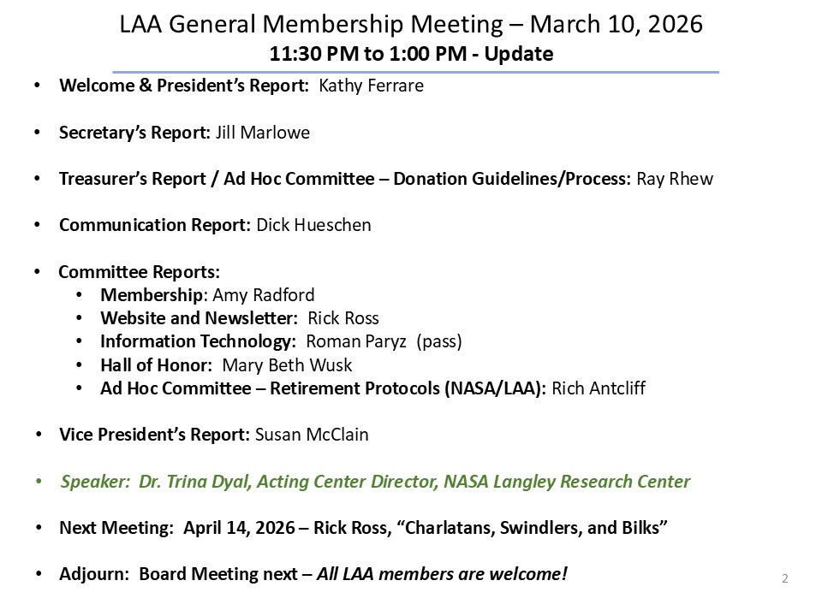
- NO DISCUSSION

President’s Report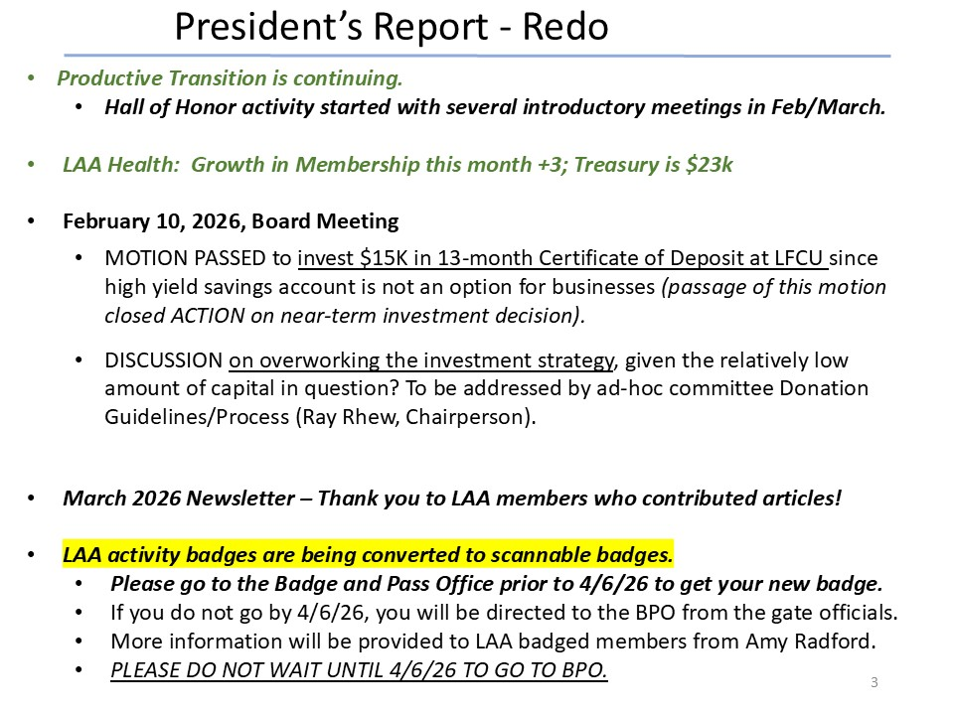
- DISCUSSION: New Activity Badges
  - Only for scanning through gate, will not work for computers (no increased capability)
  - You can go over any time (today forward) to do this, takes about 10 minutes (do not need ID, just your old activity badge)
  - May work with fitness center if they add the gym building to your access list; any orgs you are affiliated with should be able to update your scannable access
  - Will not scan before April 6
  - If anyone has difficulty, contact Amy Radford

Secretary’s Report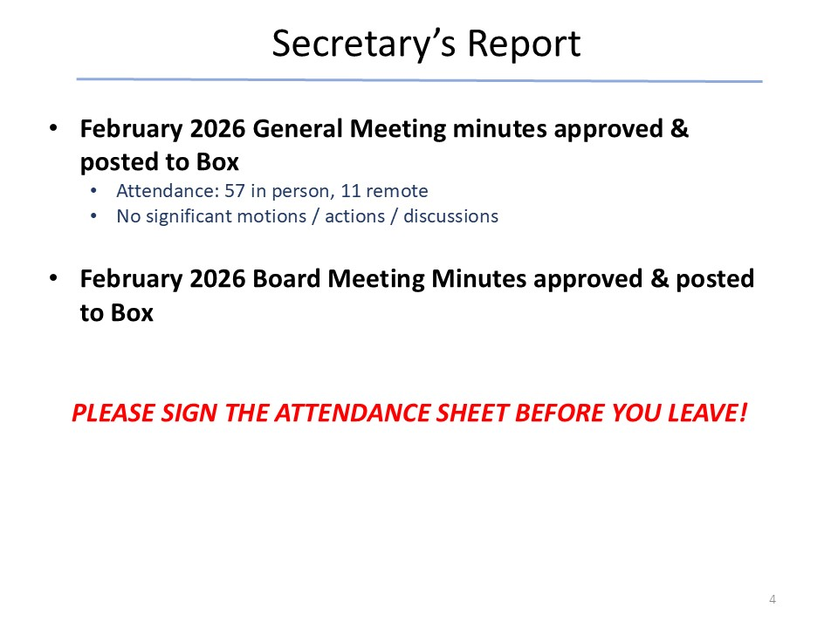
- NO DISCUSSION

Treasurer’s Report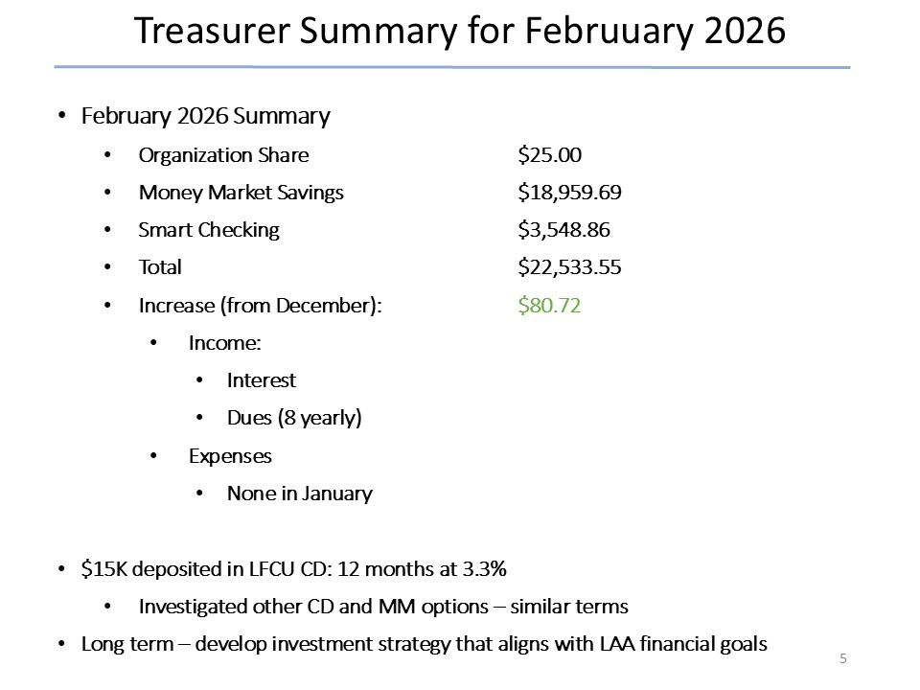
- NO DISCUSSION

Ad-Hoc Committee: Donation Guidelines/Process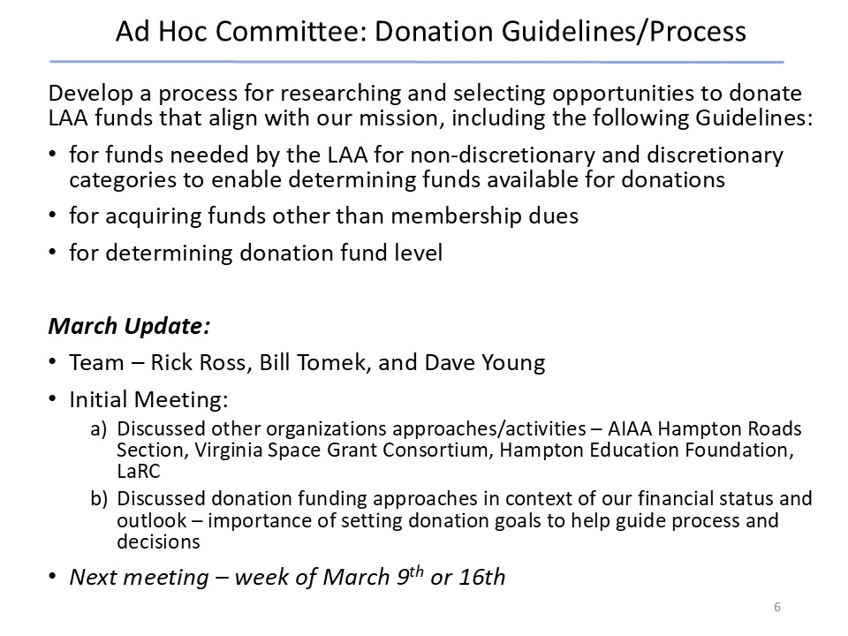
- NO DISCUSSION

In Memorium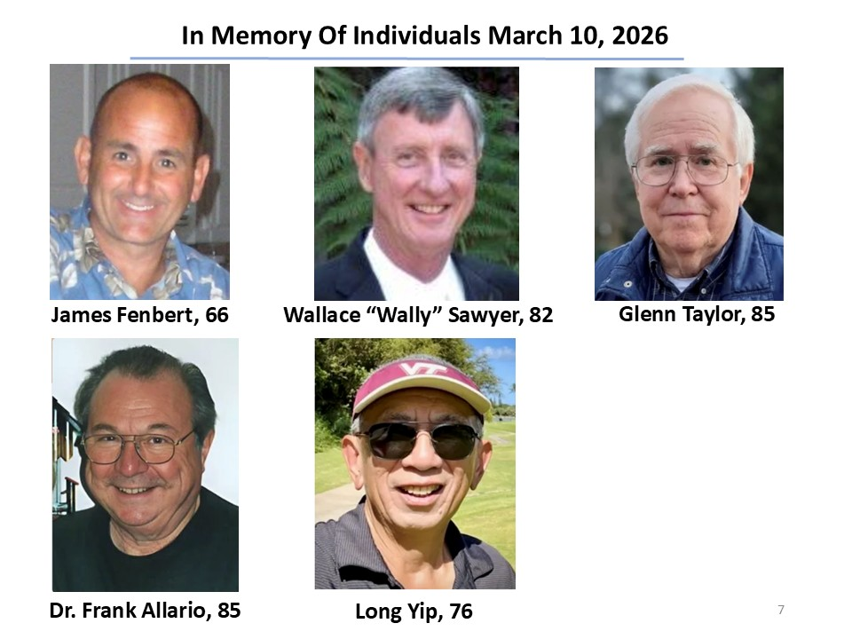
- NO DISCUSSION

Membership Report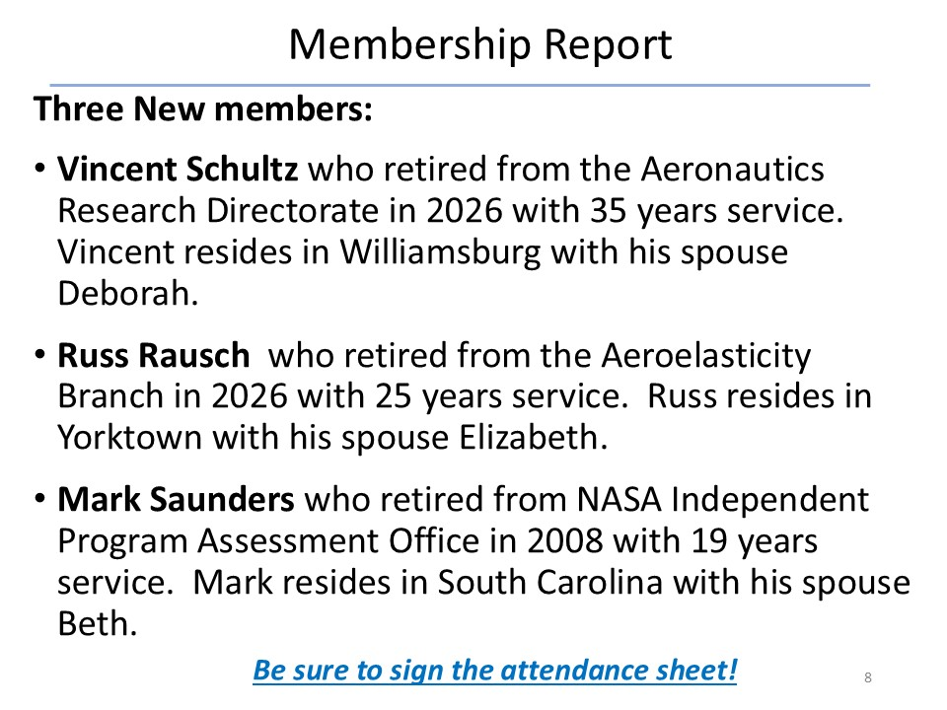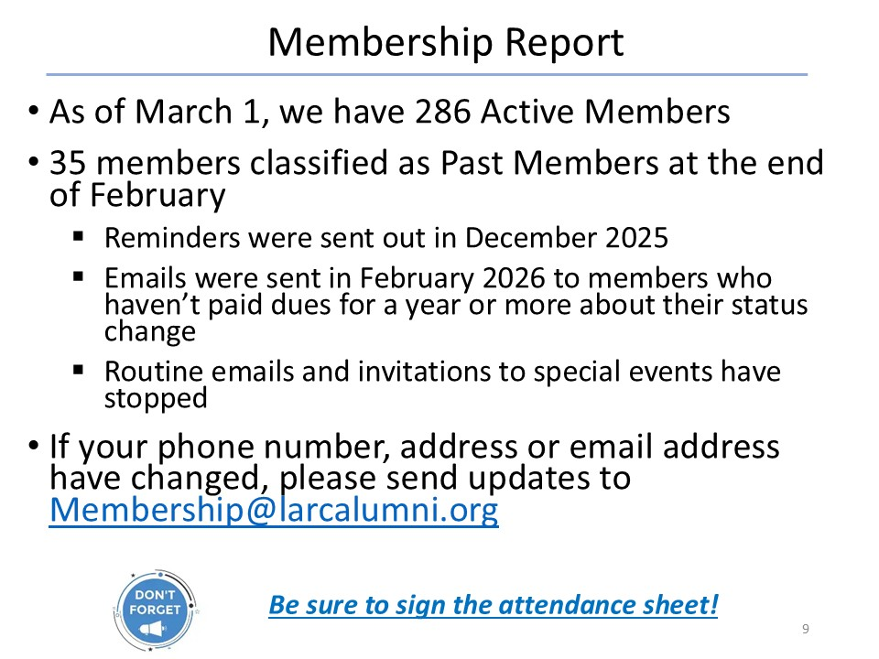

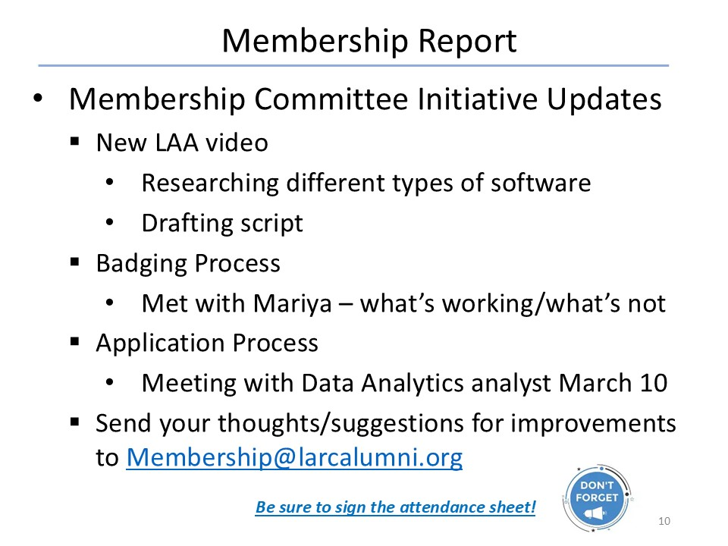
- NO DISCUSSION

Website & Publications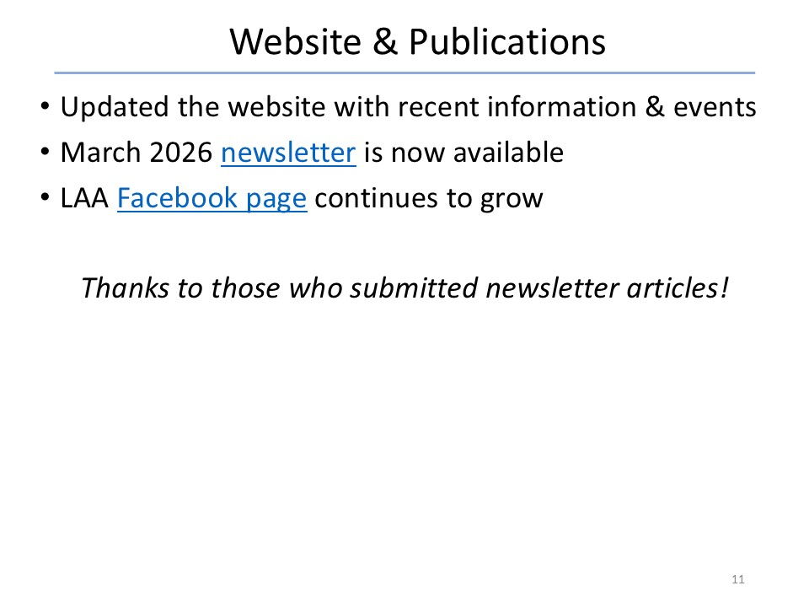
- NO DISCUSSION

Hall of Honor Committee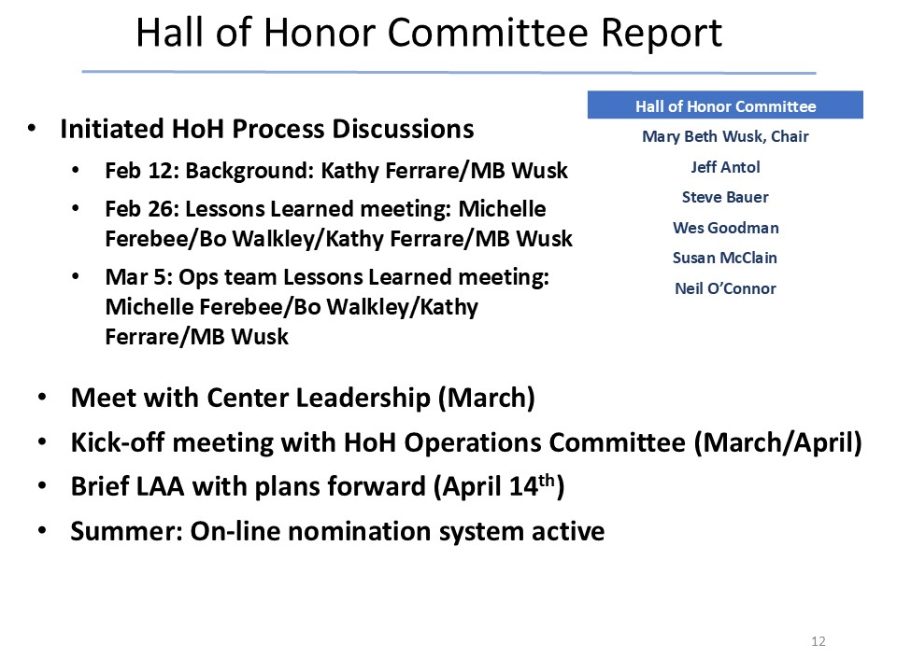
- Kathy briefed for Mary Beth
- NO DISCUSSION

Ad-Hoc Committee: Retirement Protocols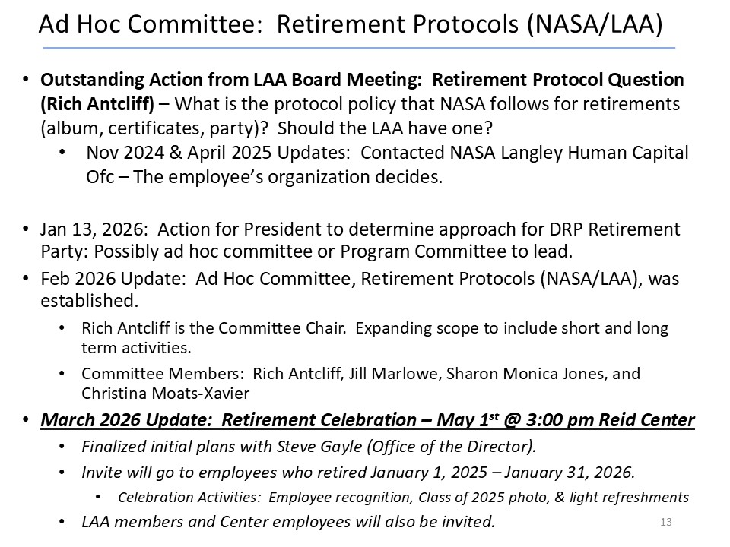
- NO DISCUSSION
- Volunteers to contact Rich (richard.r.antcliff@gmail.com)

Vice President’s Report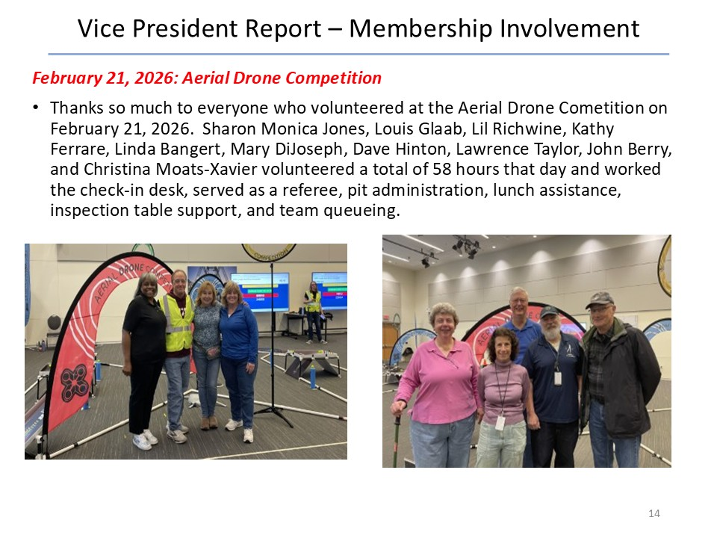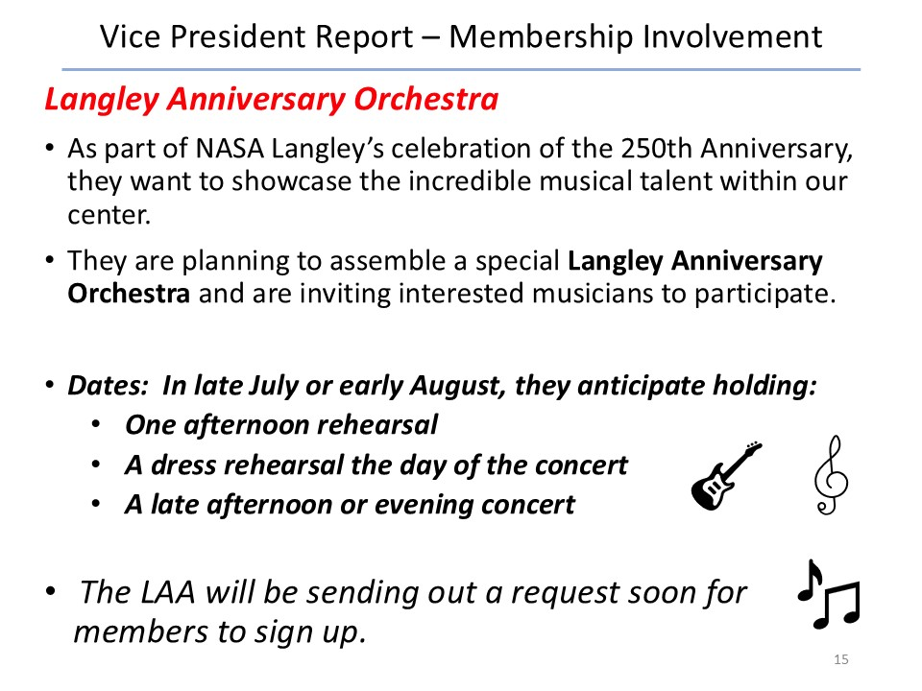
- NO DISCUSSION

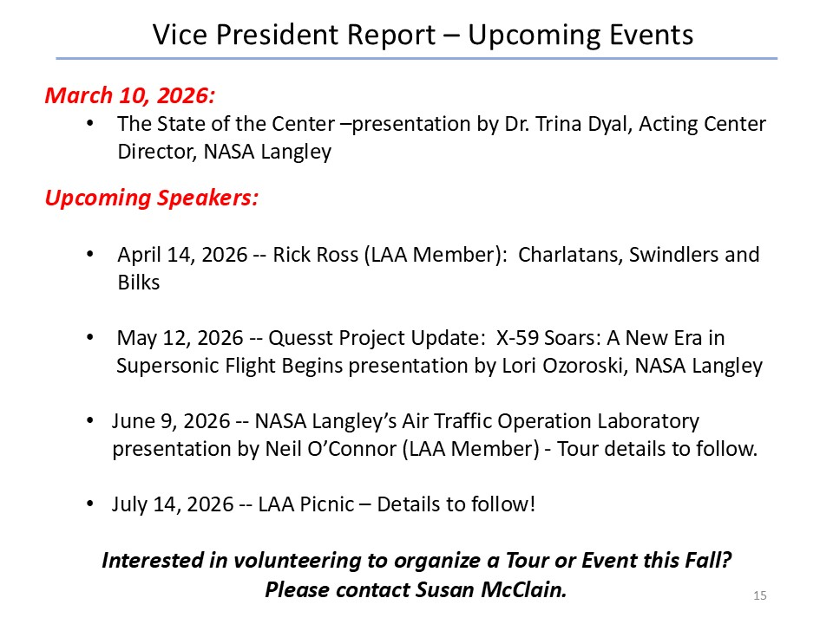
- NO DISCUSSION

Today’s Speaker

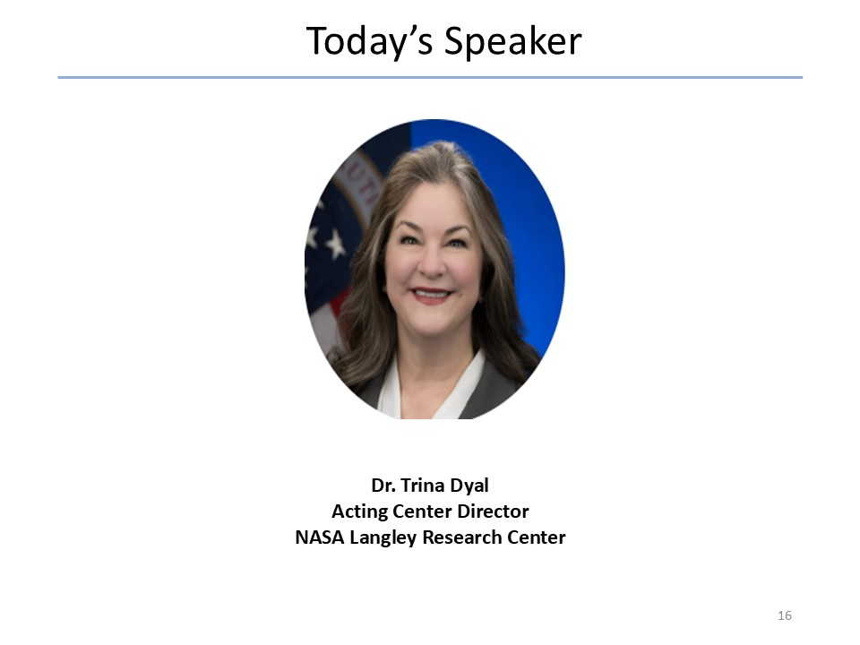
DISCUSSION
- Reprised some of the general meeting discussion
  - Will be signing certificates to honor employees
  - Anniversary Orchestra is part of making sure we remember who we are as Langley Community
  - Will also be planning a Viking 50th remembrance
- Selected highlights from presentation
  - LARC lost 16 executives (SES/ST/SL) last year, 12 remain from Jan 2025 roster
  - Current complement 1337 (1800 in FY24) + 1300 WYE
  - DRP reductions
    - Aero 565 -> 356
    - Exp 318 -> 315
    - Science 257 -> 197
    - Mission support 676 -> 490
  - Administrator advocating for Tech Force (2yr appointment) to help recover
  - NASA got $10B in OBBBA funding for infrastructure at space centers; will free OSI funding in other lines for infrastructure at other centers
  - Current strategy (back to Lesa Roe era – deliver on commitments, create future opportunities, improve along the way); next 12-14 month focus:
    - doubling down on “serve NASA and the nation” with stretch goal of 30% reimbursables (Gasbarre now reconstituting Strategic Partnerships Office, reporting to Center Director, to aggressively go after this)
    - also grow exploration contribution
- Conclusion - call for LAA Volunteers
  - FDRF ribbon cutting guides, docents, etc.
  - Supervisory Cohort keynote speakers (lost 35% of supervisors in DRP)
  - Mentor early career
  - Langley Anniversary Orchestra
  - STEM events
- Healthy Q&A on selected parts of presentation

