LAA General Membership Meeting

February 10, 2026

Summary of Motions / Actions / Discussions
- Attendance: 57 in person, 11 remote
- No significant motions / actions / discussions

Welcome
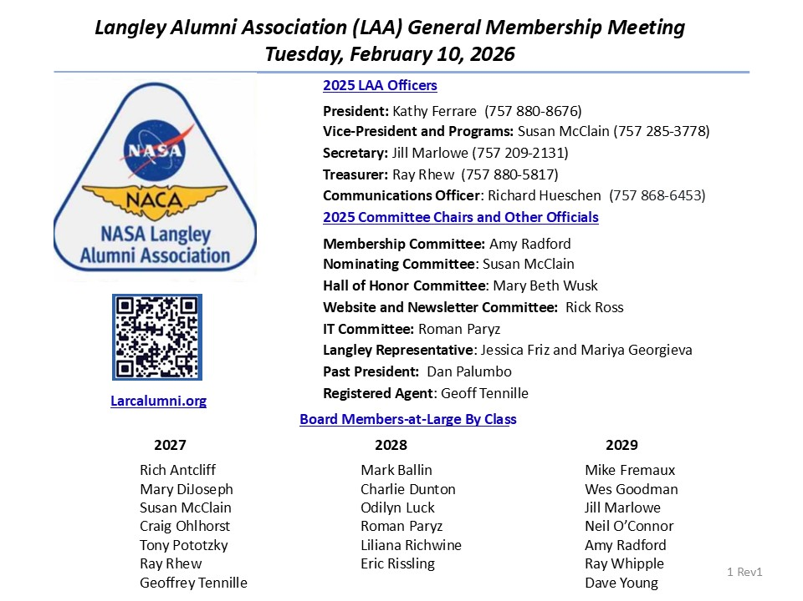
- NO DISCUSSION

Agenda
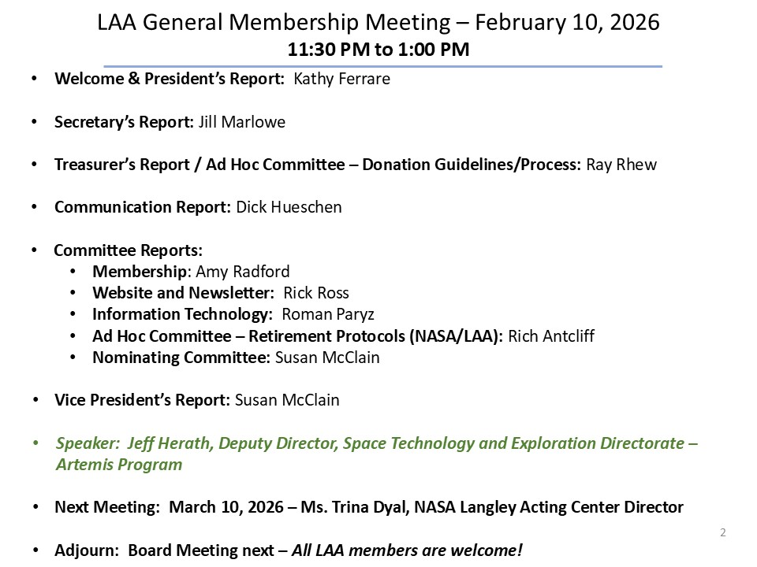
- NO DISCUSSION

President’s Report
- NO DISCUSSION

Secretary’s Report
- NO DISCUSSION

Treasurer’s Report
- Kathy: shared that Ray will be looking at moving $15K into better interest bearing option

Ad Hoc Committee – Donation Guidelines/Process
- NO DISCUSSION

In Memoriam
- Dick requested to let him know if anyone knew status of Frank Alario

Membership Report
- Dave Hinton presented for Amy who not able to attend

- NO DISCUSSION

Website & Publications
- NO DISCUSSION

IT Committee Report
- Microsoft Basic grant only allows web-based Office products vs full versions
- Any board member can request a @larcalumni.org email, used to ensure seamless transition of roles and limit exposure of personal emails of boar members

Ad Hoc Committee: Retirement Protocols (NASA/LAA)
- NO DISCUSSION

Vice President Report – Membership Involvement
- Rick/Roman endorsed this as fun and worthwhile event to support students

Vice President Report – Upcoming Events
- NO DISCUSSION

Nominating Committee
- NO DISCUSSION

Today’s Speaker: Jeff Herath
- Bio, slides posted on larcalumni.org

